Brochure of Materials

for the NSF-sponsored

Multi University Research and Training in Protection of Critical Information Infrastructures

Workshop hosted by:




June 24th- July 5th, 2013

PETE Chevron RCL Patrick F. Taylor Hall

Room 3419

WELCOME

Welcome to the second series of two faculty/student development workshops in the Protection of Critical Information Infrastructures to be held during Summer 2013. We are extremely honored that you have decided to participate this year.

The theme of the 2013 Faculty Development—Multi University Research and Training in Protection of Critical Information Infrastructure workshop, “Critical Information Infrastructure Protection,” captures the importance of critical issues on the need for cybersecurity and the many techniques that can be used to protect critical infrastructure. Here, you will find a series of activities organized to stimulate and spawn research ideas in the frontiers of technology with an objective to encourage collaborative research between the participants. The program’s contents will further detail the activities of this workshop including outlines of research lectures, group discussions on research topics, identification and preparation of research, and construction of teaching proposals based on activities from these workshops.

We hope that during your time here in Baton Rouge, you will also find some time to enjoy all the amenities offered in the area from our varied neighborhoods, cultures, landscapes, and cuisines, to shopping opportunities provided by our many malls and specialty stores.

We are pleased to have you join us this year and hope you will find this experience well worth the time spent, maybe enlightening. We anticipate this workshop will help you initiate a journey of exploration and innovation.

This brochure's material is based in part upon work supported by the National Science Foundation under Grant Number DUE-1202690. Any opinions, findings, and conclusions or recommendations expressed in this material are those of the author(s) and do not necessarily reflect the views of the National Science Foundation.
PURPOSE and MOTIVATION
Proper timely responses to a perceived security threat are of utmost importance in protecting the cyber infrastructures that facilitate interagency information sharing and on-demand information dissemination. Nowadays, collaboration requirements in the globalized world, combined with the pressing demand for information-sharing among federal agencies in the post-9/11 world, rely on the construction of secure infrastructures for dependable, situation-aware, and timely delivery of classified information. Ms. Melissa Hathaway, the former cyber-czar to President Obama’s administration, has stressed on the importance of international cooperation as well as the collaboration between public and private sectors in enforcing cybersecurity. Such close collaboration and coordination among diverse agencies need multi-level secure (MLS) infrastructures for information sharing. These infrastructures take the form of a number of interconnected heterogeneous enclaves (collections of computers within a security domain) operating at different security/classification levels and with different confidentiality requirements. Information flows into each enclave from diverse sources and is processed by customer-built, open-source, or COTS software programs before being released to other enclaves. These software programs can be uncertified and may contain malicious code or vulnerabilities that can be exploited by an insider or an outsider to leak confidential data, misclassify documents, and destroy or modify valuable information. Techniques to protect such MLS infrastructures by putting in place the applications that can carry out the responses to such perceived threats and actuators being managed from an enterprise standpoint with policies reflecting the management’s intent need to be developed.
It is widely believed that future attacks on our nation will be launched on critical information infrastructures controlling essential services rather than a conventional attack on our shores. The next “Pearl Harbor”, if it would happen, could cripple our capacity of supplying power, lodge, healthcare, food, and water and could result in the damages which are several thousand times greater than that of the Pearl Harbor tragedy in the 1940s. However, hardly anything has been done to protect our critical information infrastructures; they remain vulnerable to attacks from terrorists and rogue states. A case in point is our ever-expanding “smart electrical power grid” designed to deliver “information quality power” using networked systems for monitoring, control, and optimization. As the 2003 blackout demonstrated, failure of this critical infrastructure can paralyze life over a significant portion of the nation. However, over the last thirty years, negligence as well as lack of investment has resulted in the obvious deficiency in our current mechanisms for protecting information infrastructures crucial for generating and delivering power. The state-of-the-art protection systems for such critical information infrastructures suffer from the poor accountability of threats. Consider an attack (an alert) detected by a signature of activities: the question is how do you respond to this threat? It is interesting to know who the driving force behind this attack is. However, it is very difficult to identify the attack type and the intent of the attacker with a low false alarm rate. It is extremely difficult to predict what the end target truly is from the indications and warnings that our sensors are providing with all of the additional noise from normal traffic.
The goals of the proposed SFS project are two-fold: (1) to recruit talented Faculty/Student Scholars, to invest in their continued development, and to enhance their educational experience in protection of critical information infrastructures through training, and (2) to develop a consortium of universities, consisting of PI/Co-PIs and Faculty Scholars’ institutions, to develop sustainable research and academic partnerships to share experiences in critical information infrastructure protection and computer security research and education.
Abstracts (in Chronological Order)

Richard Koubek, June 24, 2013, 9:00-9:30
Welcome Speech and Introduction of LSU College of Engineering

S. S. Iyengar, June 24, 2013, 11:00-Noon
IMPACT OF SCIENCE & TECHNOLOGY IN THE 21ST CENTURY. Scientist vision and voice must extend to the training of next generation workforce. Investment in Science and Innovation now will result for decades to come. The convergence of Science & Technology is the focus of this talk. The speaker will present a future of Science and innovation for the 21st century. This talk covers a broad spectrum of the acceleration and commercialization of technology for the next decade.

Konstanin Busch, June 24, 2013, 1:30-2:30
Universal Steiner Trees for Efficient Data Aggregation in Sensor Networks. A fundamental problem in sensor networks is to collect and aggregate data towards a sink node with the smallest communication cost possible. We demonstrate how to efficiently achieve this goal with a universal Steiner tree that approximates the cost of any Steiner tree to the sink node. A universal Steiner tree is appealing because it alleviates the need to build a different Steiner tree for each different set of data sources. The universal construction is feasible though a clustering method that partitions hierarchically the network graph such that each node has a bounded number of clusters within a specific radius. We give an efficient universal Steiner tree construction for general network topologies which achieves a super-log approximation factor,2^{\sqrt \log n} for n nodes. We also give a poly-log approximation factor construction for planar and minor-free graphs which are more related to sensor networks.

R. (Vaidy) Vaidyanathan, June 25, 2013, 11:00-12:00
On Estimating the Area Covered by Streaming Rectangles. The problem studied is to determine the area covered by a set of axis aligned rectangles in a discrete space. The setting is one in which the space and/or number of rectangles is too large to store for offline use, or to obtain an exact solution to the problem. Therefore, a streaming input and an area estimate as output is considered. We present a transformation of the problem from two dimensions to one. Our results give approximation ratios, workspace bounds and query times that are all independent of the number of input rectangles. Our method can also exploit regularities in the input rectangle shape.

Su-Seng Pang, June 25, 2013, 1:30-2:30
Integration of Education/Research/Mentoring Programs and Strategies for Developing Winning Proposals.The Office of Strategic Initiatives (OSI) at Louisiana State University (LSU) was established in 2001. This office is led by Vice Chancellor Isiah M. Warner, Associate Vice Chancellor Su-Seng Pang, and OSI STEM Director Zakiya S. Wilson. The Vision of OSI is to support the achievements and recognition of LSU students, faculty, and staff through education and mentoring programs. The goals of OSI are to assist in raising the academic performance of students, faculty, and staff. These have been achieved through the creation and implementation of various innovative education programs funded by NSF and other agencies. The kinds of strategic initiatives being pursued include, but are not limited to: developing innovative mentoring activities, providing funding to potential and existing LSU students, coordinating efforts to generate education/training grants to support undergraduate/graduate students, establishing close alliances with other universities, supporting K-12 education, and increasing the number of external awards for students and faculty. Over the past seven years, OSI has achieved its mission through the acquisition of many programs funded through NSF, NIH, HHMI, Department of Education, Louisiana Board of Regents, and private organizations. LSU/OSI has housed the leading investigators of many educational grants, especially those currently/recently funded by NSF through I³, S-STEM, REU, GK-12, LS-AMP, AGEP, BD, SFS, etc. In this seminar, the following information will be covered: (a) Results of NSF and other educational projects, (b) Strategies for motivating and mentoring students, (c) Plans for integrating education and mentoring programs, and (d) Strategies for developing winning education/research proposals, especially those funded by NSF and NIH. After the presentation, an open discussion will follow. The audience will be invited to exchange its experiences on how to develop programs to integrate research, education, and mentoring.

Dwayne Jerro & Timothy O. Matthews, June 25, 2013, 1:30-4:00
Protection of Offshore Wind Energy Systems Critical Information Infrastructures. The proposed research and workshop discussion will focus on the development and protection of offshore wind energy systems in the United States. This work is motivated by the immediate and future need for global energy, which is driven by rapidly expanding digital and technology markets. The focus of the research will be on identifying and creating secure and adaptable information infrastructure systems that will survive and mitigate foreseeable threats, such as, cyber, physical and natural threats. A portion of this work will also incorporate computational sciences through resources from the Louisiana Optical Network Initiative (LONI) to integrate sensor databases and networks for design, operation and control of offshore wind energy systems. Discussion will also be made on integrating the sensor and control topics into an Engineering Modeling, Analysis, and Control course.

Hsiao-Chun Wu, June 26, 2013, 9:00-10:30
Game Theories for Network Technologies. Game theory has been attracting a lot of scientists and engineers due to it being an effective way to interpret the resource distribution and allocation. In this talk, basic game theoretical framework will be introduced and several typical games will be discussed. The related applications in network and telecommunication fields will be presented.

Maurice Herlihy, June 26th, 2013, 11:00-12:00
The Multicore Revolution.Computer architecture is undergoing, if not another revolution, then a vigorous shaking-up. The major chip manufacturers have, for the time being, mostly given up trying to make processors run faster. Instead, they have switched to ``multicore'' architectures, in which multiple processors (cores) communicate directly through shared hardware caches, providing increased concurrency instead of increased clock speed.
As a result, system designers and software engineers can no longer rely on increasing clock speed to hide software bloat. Instead, they must somehow learn to make effective use of increasing parallelism. This adaptation will not be easy. Conventional synchronization techniques based on locks and conditions are unlikely to be effective in such a demanding environment. Coarse-grained locks, which protect relatively large amounts of data, do not scale, and fine-grained locks introduce substantial software engineering problems. As a result, the community has increasingly turned to hardware and software models based on atomic transactions.
This talk will survey the area, with a focus on open research problems.

Rajgopal Kannan, June 26, 2013, 1:30-2:30
On the Price of Anarchy of Unsplittable Congestion Games. We consider non-cooperative unsplittable congestion games where playersshare resources, and each player's strategy is pure and consists of a subset of the resources on which it applies a fixed weight.Such games represent unsplittable resource/job allocation games as well as routing flow games. The ongestion of a resource is the sum of the weights of the players that use it, and the utility (latency cost)of the resource is any arbitrary (convex) function of the congestion. We quantify the quality of Nash equilibria in these games with the price of anarchy (PoA) which expresses how much worse is the social outcome in the worst equilibrium versus the optimal coordinated solution. Using a fundamentally new technique based on load balancing, we formulate the PoA as a maximization problem under constraints and obtain general results on the PoA of congestion games with arbitrary latency cost functions. Our maximization formulation is driven by the observation that the fractional contribution of players in a resource equivalence class towards the optimal social cost of these resources is also related to their contribution to the average price of anarchy.

Yujian Fu & Donte McDaniel, June 26, 2013, 2:30-4:00
Results of Mini-Grant and Beyond. The mini-grant was proposed to conduct work in security and robotics system in educational and research folds. It mainly focuses on the following aspects: a) First, a continuous work on the security analysis of noninterference properties on the trace based semantic execution was conducted, some interesting results are obtained and formal analysis approach was developed; b) Second, we have applied the formal modeling approach to robotics system in the sophomore class, besides, a robotics competition university wide was hosted and very positive results were collected, from which it demonstrated a strong interest from students in this area and topics; c) a conference paper in the robotics system reconfiguration was published; a student will attend the conference. Autonomous robotics systems (ARSs) consist of multiple heterogeneous objects and intelligent inferences that are expected to take appropriate actions even in unforeseen circumstances. ARSs and their reconfiguration are our main research work and have very interesting results. Two typical problems w.r.t. the ARSs were identified and studied: The first problem, addressed how to formally represent the ARSs and describe the reconfigurable behavior precisely so that the ARSs can adapt to the new changes. The second problem, focused on how to analyze and verify the formal model of the reconfiguration and ensure the correctness of the system during reconfiguration. A case study was developed for application of the approach to a humanoid robot.

Marwa Hassan, June 27, 2013, 9:00-10:30
Use of Photocatalytic Pavements for Outdoor Air Purification

Supratik Mukhopadhyay, June 27, 2013, 11:00-12:00
Liveness and Performance Analysis of Program. Analysis of termination and other liveness properties of an imperative program can be reduced to termination proof synthesis for simple loops. Among simple loops, the subset of interesting because it is common in practice and expressive in theory. Existing techniques can successfully synthesize a linear ranking function for an LSL if there exists one. However, when a terminating LSL does not have a linear ranking function, these techniques fail. In this talk we describe an automatic method that generates proofs of universal termination for LSLs based on the synthesis of disjunctive ranking relations. The method repeatedly finds linear ranking functions on parts of the state space and checks whether the transitive closure of the transition relation is included in the union of the ranking relations. Our method extends the work of Podelski and Rybalchenko. We have implemented a prototype of the method and have shown experimental evidence of the effectiveness of our method.
We also present a new technique for refining the complex control structure of loops that occur in imperative programs. We rst introduce a new way of describing program execution patterns { (+ path expressions the operators expressions have no path interleaving or skipping-over inner loops, which are the two main issues that cause impreciseness in program analysis. Our re nement process starts from a conventional path expression from the control flow graph, and aims to calculate a finite set of (+ path expressions expression (+ potentially generate an in nite set of (+ that, we use abstract interpretation techniques to prune the infeasible paths. In practice, the re nement process usually converges very quickly. In addition, we provide a su?cient condition under which it is guaranteed to converge. We have applied our method to symbolic computation of average case bound for running time of programs. To our best knowledge it is the rst tool that automatically computes average case bounds. Experiments on a set of complex loop benchmarks clearly demonstrate the utility of our too.
Supratik Mukhopadhyay, June 27, 2013, 1:30-2:30
A Type-theoretic Framework for Automated Synthesis of Workflows in Service-oriented Computing. We describe a technique for automatic synthesis of workflows in service-oriented systems from a typetheoretic specification of coordination requirements. The technique presented involves formal semantics-based, automatic synthesis of service coordination workflows from the business logic of the clients using type and effect inference. The type and effect deduction, apart from synthesizing the workflow, provides formal proofs that the business requirements of the clients in a service-oriented system are met. The service descriptions and the business requirements are specified as a set of type judgements in an (intuitionistic) type theory. Workflows can be generated from a (type and effect) inference of the requirements from the “service theory”.

Li Yang & Eric Reinsmidt, June 27, 2013, 2:30-4:00
Authentication in Mobile-Cloud Environment. Mobile devices are seeing an increase in usage in recent years and mobile security becomes important in part due to the shift of computing landscape towards mobile devices. Security and assurance of mobile computing is vital to the normal functioning in people’s lives, and our social, economic and political systems. We will discuss a novel system that authenticates users, devices and a remote server in a mobile computing environment based on fuzzy vault, digital signature and zero-knowledge authentication. However, since mobile devices can be lost or stolen, it is important to not only authenticate the device, but also authenticate the user of the device. Finally, as in any client-server model, the server must be authenticated as well. Client and server authentication is provided using digital signatures, while the user is authenticated using a fuzzy picture password technique. Secure communications are provided by using an AES session key generated by a Diffie-Hellman key exchange.

Stuart Rubin, June 28th, 2013, 9:00-10:00
The KASER Key to Computational Intelligence.This talk will cover the modeling of the creative human thought process through the use of Knowledge Amplification by Structured Expert Randomization (KASER). These software devices operate on the principle of Kolmogorov Complexity. Since their learning is based on randomization theory, they are not subject to the limitations imposed by the Incompleteness Theorem. However, the piper is paid in that they are subject to occasional error. Nevertheless, just as we accept heuristic solutions to NP-hard problems such as the TSP, we need, for many domains, to sacrifice deductive validity for inductive possibility to advance knowledge acquisition by entering the realm of human reasoning. A movie of the first operational KASER will be shown. Moreover, both theory and applications will be covered in this hour-long talk, which will be suitable for faculty and students alike.

Su-Seng Pang, June 28, 2013, 1:30-2:30
Discussion on Mini-grant Proposals. Dr. Pang will lead the brainstorm discussion on various mini-proposal ideas that will be developed by faculty/student Scholars. Throughout this training workshop, faculty/student scholars will become familiar with the state-of-the-art technological advancement in the protection of critical information infrastructures. By using the mini-grant, each faculty/scholar pairs will be able to extend their gained research/education training to their home institution. The topics of the mini-proposal include, but are not limited to the following: Course or curriculum development, Laboratory development, Research proposal. Each mini-proposal should have substantial student involvement mentored by faculty members. Potential outcomes of mini-grants may include, but not limited, to the following: (i) Provide the valuable hands-on experience to the undergraduate and high-school students on the focused topics; (ii) Provide the state-of-the-art knowledge via tutorials and seminars; (iii) Demonstrate the emerging science and engineering technologies to undergraduate and high-school students; (iv) Facilitate or enhance computer programming and computational thinking skills of undergraduate students; and (v) Motivate quality engineering/science fairs for high school students. These, along with others, will be discussed during this seminar.

Jason Black & Olivia Wilson, June 28, 2013, 2:30-4:00
Attracting K-12 Students to Consider Computer Security as a Career through Competition – A Challenged Approach, Lessons Learned and Future Implementation Plan. There is general agreement that the need for computing professionals in the near term is increasing, while enrollment in computer science degree programs is decreasing. This need is more evident in the more specialized but high-need areas of computing, such as mobile computing, bioinformatics and computer security, yet these areas hold the most for prospective employers in job security, professional advancement, and societal impact. FAMU hoped to address this situation by attracting pre-college students to consider computer science and, more specifically, computer security, at the collegiate level through participation in a Cyber-Triathlon competition, to be held at FAMU. The plan called for a one-day event on our campus, allowing high school juniors, seniors and FAMU Freshmen student participants opportunities to experience encryption and cryptography problem-solving techniques, use their programming skills, and compete for prizes. Participants were self-selected and recruited from local high schools and FAMU courses, and applied for the program through a website developed from the competition. Unfortunately, the event was cancelled due to lack of participation. This discussion presents the recruitment and design model developed for this event, describes recruitment results, lessons learned, and suggestions for future implementation, and presents a infrastructure model for full-scale successful implementation of this event in upcoming semesters, including plans for development and submission of a grant proposal for adequate funding for this event.

Mark Luker, July 1, 2013, 9:00-10:30
ALL OPINIONS EXPRESSED ARE THOSE OF THE SPEAKER

Nicolas Diogo & Treston Hall, July 1, 2013, 11:00-12:00
Networks and Applications Security.With the rapid expansion of cyber activities in our daily lives, especially the sophisticated technique of hacking activities on cyber space, it is vital to put in place a systematic protection approach to secure networks and applications. A vulnerability assessment simply detects and reports noted vulnerabilities. Penetration testing exploits the vulnerabilities to determine whether unauthorized access or other malicious activities are possible.
In this presentation, we will examine Penetration Testing Methodology as well as exploring some tools for penetration testing. Although there are different types of penetration testing, the two most general approaches that are widely accepted by the industry are Black-Box and White-Box. These approaches will be discussed as well.

Vir Phoha, July 1, 2013, 1:30-3:00
Some Recent Results In Non-Zero Effort Attacks On Behavioral Continuous
authentication Systems.

Peter Kelleher, July 1, 2013, 3:00-4:00

Jeffrey M. Bradshaw, July 2nd, 2013, 9:00-10:30
KAoS Policy Services for Human-Agent-Robot Teamwork and Network Protection. Tomorrow's world will be filled with software agents and robotic agents embedded everywhere in the places and things around us. Providing a pervasive web of sensors and effectors, teams of such agents will function as cognitive prostheses—computational systems that leverage and extend human intellectual, perceptual, and collaborative capacities. While these heterogeneous cooperating entities may operate at different levels of sophistication and with dynamically varying degrees of autonomy, they will require some common means of representing and appropriately participating in joint tasks. Just as important, developers of such systems will need tools and methodologies to assure that such systems will work together reliably, naturally, and effectively, even when they are designed independently.

In this talk, we introduce KAoS, a policy and domain services framework based on W3C’s OWL ontology standard. Policies are being increasingly used for automated system management and controlling the behavior of complex systems. The use of policies allows administrators to modify system behavior without changing source code or requiring the consent or cooperation of the components being governed. We will describe our approach to maintaining resilience in agent teams by combining policy governance with principles of human-agent teamwork and organic resilience. We will illustrate examples of applications of this approach in human-robot reconnaissance tasks, in governance of network communications, and in cyber defense.

Niranjan Suri, July 2, 2013 11:00-12:30
Agile Computing. Wirelessly networked dynamic and mobile environments, such as tactical military environments and disaster recovery operations, pose many challenges to building distributed computing systems. A wide variety of node types and resources, unreliable and bandwidth constrained communications links, high churn rates, and rapidly changing user demands and requirements make it difficult to build systems that satisfy the needs of the users and provide good performance.

Agile computing is an innovative metaphor for distributed computing systems and prescribes a new approach to their design and implementation. Agile computing may be defined as opportunistically discovering, manipulating, and exploiting available computing and communication resources. The term agile is used to highlight the desire to both quickly react to changes in the environment as well as to take advantage of transient resources only available for short periods of time.

This talk will introduce the Agile Computing Middleware, and then focus on the key components that compose the middleware – the Mockets Communications Library, the Group Manager discovery service, the DisService peer-to-peer information dissemination system, the DSPro proactive dissemination system, and finally the NetProxy that integrates all of the above capabilities with legacy applications.

Jianhua Chen, July 2, 2013. 1:30-2:30
Text Mining for Automatic Ontology Extraction from Domain Texts. An ontology is a conceptualization of a domain, which encodes important domain-specific knowledge. Automatic extraction of ontology from domain texts is essential for building large-scale knowledge-based systems by exploiting the vast amount of textual data readily available nowadays. We develop a set of techniques for automatically extracting ontological components (concepts, taxonomic and non-taxonomic relations) from domain texts. A combination of information retrieval metrics, lexical knowledge
bases, machine learning and statistical approaches produces an effective way
for the ontology learning task. Empirical studies show that our techniques
can produce good quality ontology components efficiently.

Michael Mislove, July 2, 2013, 2:30-4:00
Analyzing Computational Models. Computational processes require models to facilitate analysis and provide assurance that processes perform as expected. For example, automata are useful for describing how a process will evolve during a computation. But automata soon become unable to accommodate process dynamics as the complexity increases. Even in simple settings, it is difficult to use automata or similar models to prove processes satisfy certain properties (specifications). This is especially true when processes involve probabilistic constructs that arise for instance in the security setting. Crypto-protocol analysis in particular requires modeling participants who make random choices, and here the issue is not so much the outcome of a single run, but rather what happens over several runs. In this talk, I will describe some denotational models for computation that are designed to allow more abstract analyses than the lower-level models such as automata. By abstracting away from details, these models allow one to prove processes satisfy specified properties, and they often have automated aids for generating counterexamples to show how processes can fail to satisfy certain properties. The talk will include examples to illustrate the analysis of specific processes.

Thomas Sterling, July 3, 2013, 9:00-10:30
The Essential Runtime System Infrastructure for Exascale Computing.High performance computing (HPC) is experiencing the most dramatic change in twenty years as it confronts the most severe challenges to the future of scalability since the adoption of commodity cluster. Constraints on power and as a consequence clock rate as well as limitations to microprocessor core architecture has forced reliance on multicore and GPU heterogeneous architectures to achieve continued performance gain with Moore's Law. Conventional computing models and programming interfaces are unlikely to address these challenges. To achieve Exascale computing by the end of this decade will demand a new paradigm for dynamic adaptive resource management and task scheduling. Central to this dramatic shift in methodology is the development and application of runtime systems for high performance computing. This address will present the accomplishments of recent work on the ParalleX execution model and the HPX runtime system software developed to enable unprecedented efficiency and scalability to enable extreme scale processing capability including Exascale in the near future.

Kaliappa Ravindran & Hassan Elhalaby, July 3, 2013, 1:30-2:30
Testbed for Research & Training in Discrete Event Modeling of Distributed Infrastructure Management Systems. At the CUNY Distributed Systems Management Lab, we impart research & training to students about the scientific methods, techniques and tools for the discrete-event modeling of real-world critical infrastructure systems (e.g., power grids, healthcare facilities, transportation systems). The infrastructure systems are complex to model and analyze due to the intrinsic physical and computational characteristics of underlying cyber-resources: such as geographic spread-out, decentralized administrative control, and subsystem-level heterogeneity. While these characteristics are the essential traits to make the infrastructure systems useful for the society, they also open up vulnerabilities to failures and external attacks. Methods to protect the systems require a deeper understanding of the interactions between various components and the incidence of various hostile external environment conditions. To understand the protection methods and the system robustness, we teach model-based simulation techniques to students with a focus on the case studies of real-world systems.

Marcio DeQueiroz, July 3, 2013, 11:00-12:00

James Digby, July 3, 2013, 2:30-4:00

Ryan Cooney, July 5, 2013, 9:00-10:00

Eugene Kennedy, July 5, 2013
Summer Workshop Evaluation, Surveys, and Exit Interview. Our project evaluator, Dr. Eugene Kennedy, will lead this evaluation, surveys, and exit interview session on the last half day of the summer workshop. A rigorous evaluation methodology and procedure to ensure the success of this project will be designed and implemented by Dr. Kennedy that will improve the overall accomplishment of this project. Furthermore, this will be very beneficial for the 2nd year workshop, being held in 2013. Surveys will be completed for each Faculty/Student Scholars. In addition, an exit interview will be conducted by Dr. Kennedy and PI-Co-PIs with all Faculty/Student Scholars.
Biographies (in Alphabetical Order)

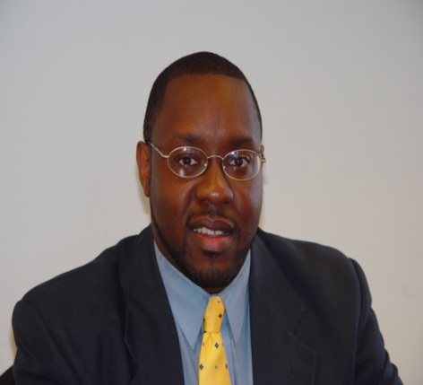
Jason Black, Florida A&M University

Jason Black received his B.S. in computer and information sciences at Florida A&M University, his M.S. degree in computer science from Georgia Institute of Technology and his PhD in computer science from Florida State University. After receiving his PhD, Jason returned to his undergraduate department, where he currently is an Associate Professor and Coordinator of Recruitment, Outreach and Scholarships. Jason is also FAMU Co-PI of the STARS Alliance and advisor for the students in the Student Leadership Corps (SLC). Additionally, Jason was Principal Investigator for an NSF S-STEM project, African-American Women in Computer Science (AAWCS), a scholarship program designed to recruit underrepresented woman and provide financial assistance, career and professional development, and networking. Jason was also Co-PI for the NSF ITEST TRI-IT Project, a program designed to motivate high school girls toward careers / college majors in computer science. Jason’s areas of research include mobile computing, gaming for educational purposes (called Game-Based Learning or Serious Games), and collaborative learning. He is currently investigating ways to develop console games (such as xBox or Wii) to teach programming language courses (such as C++). Additionally, he is working on context-awareness in mobile information systems, as well as remote or extreme programming via mobile devices.

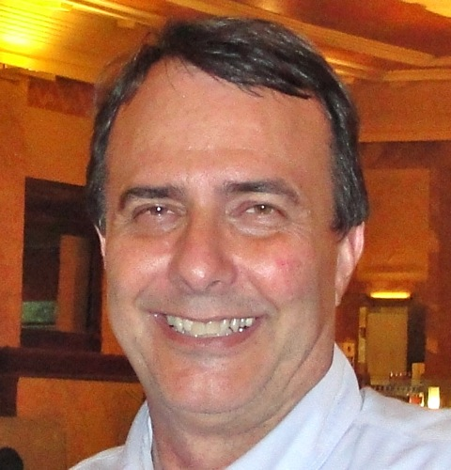
Jeffrey M. Bradshaw, Florida Institute for Human and Machine Cognition

Jeffrey M. Bradshaw (Ph.D., Cognitive Science, University of Washington) is a Senior Research Scientist at the Florida Institute for Human and Machine Cognition (IHMC) where he leads the research group developing the KAoS policy and domain services framework. He co-leads the group developing IHMC’s Sol Cyber Framework and the Luna agent framework. Formerly, Jeff led research groups at The Boeing Company and the Fred Hutchinson Cancer Research Center. Though his earliest publications were focused on memory and language, Jeff’s research focus soon turned to a wide variety of topics relating human and machine intelligence. With Ken Ford, he edited the seminal volume Knowledge Acquisition as a Modeling Activity, and became well known for his role in helping develop a suite of successful methodologies and tools for automated knowledge acquisition. While at Boeing, he founded the emerging technologies group of the Aviation Industry Computer-Based Training Committee (AICC). Jeff helped pioneer the research area of multi-agent systems, and his first book on the topic, Software Agents, became a classic in the field and a best-seller for The MIT Press.

Jeff has been a Fulbright Senior Scholar at the European Institute for Cognitive Sciences and Engineering (EURISCO) in Toulouse, France; a visiting professor at the Institut Cognitique at the University of Bordeaux; is former chair of ACM SIGART; and former chair of the RIACS Science Council for NASA Ames Research Center. He served as a member of the National Research Council (NRC) Committee on Emerging Cognitive Neuroscience Research, was an advisor to the HCI and Visualization program at the German National AI Research Center (DFKI), and was a scientific advisor to the Japanese NEC Technology Paradigm Shifts initiative. He currently serves as a member of the Board on Global Science and Technology for the National Academies and as an external advisory board member of the Cognitive Science and Technology Program at Sandia National Laboratories. He is an Honorary Visiting Researcher at the Center for Intelligent Systems and their Applications and AIAI at the University of Edinburgh, Scotland, a member of the Graduate Faculty at the Florida Institute of Technology, a faculty associate at the University of West Florida. In partnership with Autodesk Research, Jeff leads IHMC participation in the Advanced Technologies for Life-Cycle Management of Sustainable Building Performance initiative and is a member of the Parametric Human Consortium. Jeff served for over a decade on the Board of Directors of the International Foundation for Autonomous Agents and Multiagent Systems. With Robert Hoffman and Ken Ford, he serves as co-editor of the Human-Centered Computing Department for IEEE Intelligent Systems, of a new volume entitled Essays on Human-Centered Computing (with Robert Hoffman, IEEE Press, in press). In 2011, he received the Web Intelligence Consortium Outstanding Contributions Award.

Konstanin Busch – Louisiana State University

Costas Busch is currently an assistant professor in the Computer Science Department at LSU. He received a B.Sc. (1992) and M.Sc. (1995) in Computer Science from University of Crete, Greece. He has obtained a PhD in Computer Science from Brown University (2000). His research interests are in the following areas: theory of distributed computing, distributed algorithms and data structures, design and analysis of communication protocols for wireless, sensor, and optical networks, data directories for wireless sensor networks, data streaming algorithms, and algorithmic game theory. He has several publications in theoretical computer science conferences and journals including Symposium on Theory of Computing (STOC), Symposium on Foundation of Computer Science (FOCS), Journal of the ACM, and SIAM journal on Computing. He has also served in the program committees of SPAA, DISC, MOBIHOC, IPDPS, ICDCS, DCOSS. His research is funded by the National Science Foundation.

Jianhua Chen, Louisiana State University

Dr. Jianhua Chen received the Ph.D. in Computer Science in 1988 from Jilin University, China. She joined the Computer Science Department of Louisiana State University in Fall 1988. Dr. Chen is currently an associate professor in the Division of Computer Science and Engineering, School of EECS, Louisiana State University. Dr. Chen’s research interests include Artificial Intelligence, machine learning, data mining, text mining and natural language processing, intelligent information retrieval, and social network analysis.

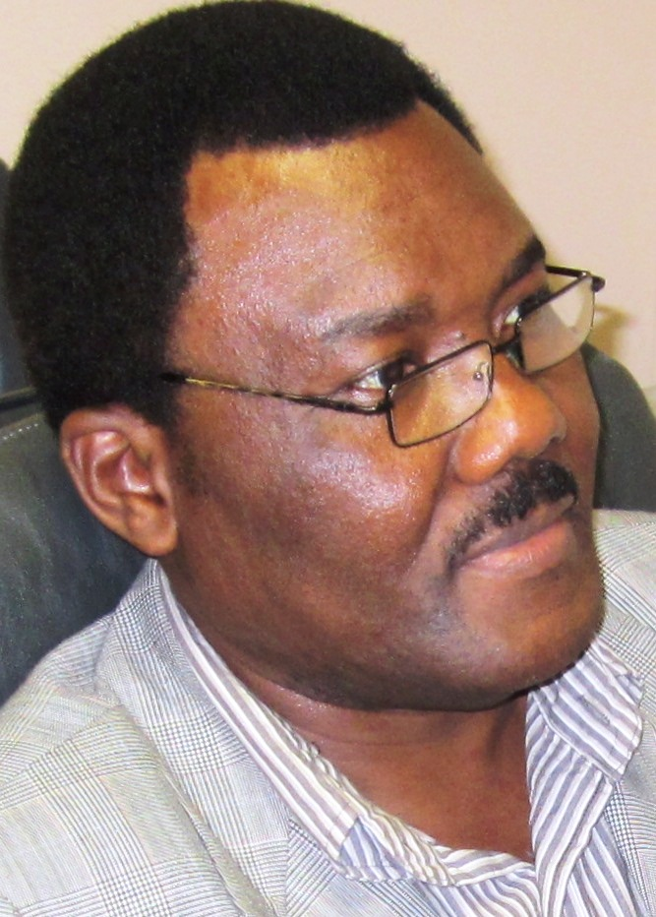
Nicolas Diogo, Florida Memorial University

Nicolas Diogo is an Assistant Professor in the Department of Computer Science, Mathematics and Technology at Florida Memorial University. He coordinates the Computer Information Systems Undergraduate Program and the Computer Educational Technology Graduate Program. As a faculty member, he teaches many computer technology courses at the undergraduate and graduate levels. His research and teaching activities have focused on issues of computer technologies into businesses. He has conducted several professional developments to teachers on how to successfully integrate computer technologies across curriculum. His current research themes focus on computer internetworking security, computer infrastructure security and control.


Hassan Elhalaby, City University of New York

My name is Hassan Elhalaby. I attended The City College of New York (CCNY), which belongs to the academic institution of The City University of New York (CUNY). At CCNY I achieved my B.S. degree in Computer Science in February 2013. I enjoy studying computer science, mostly the theoretical aspect. As part of my education, I took elective computer science courses in digital libraries, web-app development, computer networking, and compiler construction. One of the projects worth mentioning is my senior design project. I worked with a group to design and implement a fruit recognition system. The algorithm used shape, color, and texture to determine the fruit. The project has a lot of uses in the real world, such as it's use to help teach individuals using human interaction to learn through the use of a computer. Another interesting aspect is it's ability to possibly automate the harvesting process when it comes to farming.

I am also very interested in working with simulation softwares to study real-life problems. Simulation is a powerful tool, and when used properly can improve and aid us in coming up with real solutions to problems we currently have. In researching such a field an interesting problem that can be studied is given some data about an area, how can one simulate the best locations for placing emergency services, such as a fire departments, and emergency medical services. Can the 911-dispatcher system be reconfigured to work more efficiently? What data would be worth looking at in conducting such a study? Such problems can be studied and simulated, to give a good picture what one can do to improve these services!

The field of computer science is very broad, and certainly exciting. One can use it as a set of advanced professional tools to go about researching what interests each individual. However, one must always remember the ethical side, and responsibility that comes with such power.

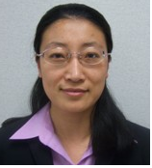
Yujian Fu, Alabama A&M University

Dr. Yujian Fu earned her Ph.D. degree in School of Computing and Information Science at Florida International University in 2007. Since then, she joined the Department of Computer Science at the Alabama A&M University as the tenure track assistant professor. Dr. Fu’s research falls in several areas, including the software verification, software quality assurance, runtime verification, and formal methods. Dr. Fu’s recent research focuses on the modeling and analysis of automobile systems and security analysis of cyber physical systems. She has several publications on the verification of software design model, formal analysis of robotics systems and modeling of smart grid systems. Dr. Yujian Fu also serves as reviewers of several journals and conferences. She is currently a member of IEEE, ACM, ASEE, and AAS.


Scott Graham, Florida International University

Dr. Graham is the Assistant Director, Research, for FIU's School of Computing and Information Sciences (SCIS) and serves as Program Coordinator for FIU SCIS's NSF PIRE and CREST awards. As Assistant Director for Government Relations of FIU’s High Performance Database Research Center and its NSF Industry/University Cooperative Research Center (I/UCRC), he has assisted their Director, Naphtali Rishe, in overseeing projects totaling over $45 million. His areas of interest include program management, broadening participation, database modeling, Internet applications, and computer architecture. Dr. Graham received his Ph.D. in Computer Science from FIU and his BSE in Computer and Information Engineering Science from the University of Florida. He has authored more than forty publications covering his areas of interest and is a member of both Tau Beta Pi and Upsilon Pi Epsilon honor societies. He currently teaches Technology in the Global Arena, a required global learning course for all CS & IT undergraduates at FIU.


Treston Hall, Florida Memorial University

Treston Hall was born in the city of Deerfield Beach, Florida in 1992. He graduated from Deerfield Beach high School in 2010 and is right now furthering his education in Miami gardens at the School of Florida Memorial University. Treston is currently a junior whom is majoring in computer science and one day plans to be a computer information systems manager.

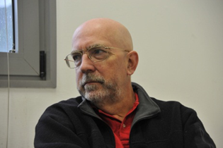
Maurice Herlihy, Carnegie Mellon University

Maurice Herlihy has an A.B. in Mathematics from Harvard University, and a Ph.D. in Computer Science from M.I.T. He served on the faculty of Carnegie Mellon University, on the staff of DEC Cambridge Research Lab, and is currently Professor in the Computer Science Department at Brown University.

He is the recipient of the 2003 Dijkstra Prize, the 2004 Goedel Prize, the 2012 Dijkstra Prize, and the 2013 IEEE McDowell Award. He is an ACM Fellow and a member of the National Academy of Engineering.

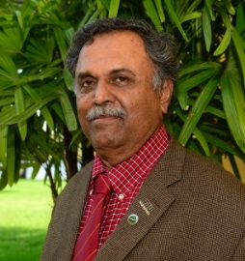
Ram Iyengar, Florida International University

Dr. S.S. Iyengar is currently the Ryder Professor and Director of the School of Computing & Information Sciences at the Florida International University, Miami, Florida, since August 2011 and before he was the Roy Paul Daniels Professor and Chairman of the Computer Science Department at Louisiana State University. During his tenure at LSU he lead the Wireless Sensor Networks Laboratory and the Robotics Research Laboratory. He has also authored/coauthored 8 textbooks and edited 12 books in the areas of Distributed Sensor Networks, Parallel Programming and Graph Theory, published in CRC Press/Taylor and Francis/John Wiley/Springer-Verlag/Prentice Hall/Chinese). He is the Fellow of IEEE, Fellow of Association of Computing Machinery (ACM), American Association for the Advancement of Science (AAAS), Member European Academy of Science (EURASC), and Fellow of The Society for Design and Process Science (SDPS). He is a Golden Core member of the IEEE-CS and a recipient of the Lifetime Achievement Award for Outstanding Contribution to Engineering Awarded by Indian Institute of Technology, Banaras Hindu University, ICAM, 2012. He received the Distinguished Alumnus award of the Indian Institute of Science. He has published over 400 articles, 40 keynote speeches, yearly workshops at Raytheon, Army Research, and Indo-US Workshop for sensor network, 3 patents and 5 patent disclosures pending, supervised 50 Ph.D. dissertations and led the new faculty hiring at FIU and LSU. Further, Iyengar is the founding Editor-In-Chief of the International Journal of Distributed Sensor Networks and has been an Associate Editor for IEEE Transaction on Computers, IEEE Transactions on Data and Knowledge Engineering, and guest Editor of IEEE Computer Magazine. He has been an editorial member of many IEEE journals in advisory roles. His research interests include Computational Sensor Networks (Theory and Application) Parallel and Distributed Algorithms and Data Structures Software for Detection of Critical Events Autonomous Systems Distributed Systems Computational Medicine. G-Index: 50 and his papers are cited more than 6000 times. He is also a member of the IEEE Fellow reviewers Committee and he was an ACM National lecturer/IEEE Distinguished Visitor/SIAM Distinguished National Lecturer. He won LSU Distinguished Research Master Award/Distinguished Excellence Award etc. He recently won the Florida Innovation Technology Award in 2012.

Dr. Iyengar was nominated for the Member of the National Academy of Engineering in 2012.

Following his Doctorate, Dr. Iyengar worked at Oakridge National Labs/Jet Propulsion Lab and laid a foundation to his academic careers at Louisiana State University, and Florida International University. During the intervening three decades of his career, research interest spanned an incredibly wide spectrum, but there is a distinct pattern. There are several distinct periods. (i) High Performance Parallel and Sequential High Performance Parallel and Sequential Algorithms for various problems in Image Processing Applications,1975-1990. (ii) Theory of multidimensional Signal/Image Integration and Sensor Fusion Problems, (Fundamentals and Applications), 1988-2000. (iii) Contribution to Distributed Sensor Networks (2000-Present).During his early years as a professor his steadfast commitment to his new adopted country can perhaps be described through his long carrier spanning over 40 years of research which was induced by Department of Navy, Naval Research Laboratory. Techniques developed from these domains had a profound impact in transferring into collaborations to aerospace, commercial and industrial grade applications. Many of his research findings has been proven and inspired

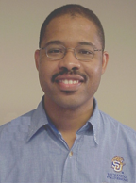
H. Dwayne Jerro, Southern University

Dr. H. Dwayne Jerro received his Ph.D. degree in Mechanical Engineering from Louisiana State University in 1998. In 2011, he was promoted to the rank of Professor in the Mechanical Engineering Department at his alma mater, Southern University. Prior to his full time roll at Southern University, he held a joint-faculty appointment (JFAP) in the Mechanical Engineering Departments at both Louisiana State University (LSU) and Southern University (SU) from 2002 to 2007. Prior to his JFAP appointment, he served as an Assistant Professor in the Mechanical Engineering Program at Louisiana Tech University for three years. He also has experience working for Composite Materials Laboratory at LSU and Delco Electronics (a unit of General Motors, but now Delphi) in Kokomo, Indiana. Dr. Jerro’s areas of interest are Wind Energy Development, Robotics, Modeling and Simulation, High Performance Computing, and Materials Science. He enjoys teaching engineering mechanics and design courses. He has worked on various projects involving diverse aspects of composite materials and advanced metal alloys. He and his students have published numerous journal and conference proceedings papers related to composite materials alone. He also has an interest in educational research which seeks to learn “how people learn,” including the use of concept mapping. Recently, he has been active in robotics and computing education and research. The heart of his robotics activities has been on increasing youth (K-12) interest in the Science, Technology, Engineering, and Math (STEM) career fields. Since 2007, he has led educational Robotics camps aimed at exposing youth and their teachers to the STEM disciplines. Dr. Jerro’s research and educational activities have allowed collaboration with universities, private companies, and several federal governmental laboratories and agencies. Some of these agencies include the Louisiana Space Consortium (LaSPACE), Office of Naval Research, NASA, the National Science Foundation (NSF). Currently, he a Co-PI of the LONI (Louisiana’s high speed Optical fiber Network) Institute, which is a $1 million grant to Sothern University, which focuses on implementing and engaging high performance computing (HPC) resources to solve massive engineering and scientific problems. He is excited about the opportunity to utilize this resource in the development of offshore wind energy systems.

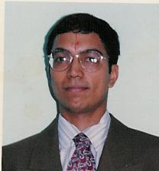
Rajgopal Kannan, Louisiana State University

Rajgopal Kannan obtained his B.Tech in Computer Science and Engineeringfrom IIT-Bombay in 1991 and the Ph.D in Computer Science from theUniversity of Denver in 1996. He is currently a Professor in the ComputerScience department at Louisiana State University. His areas of interest are in algorithmic game theory, economics of resource sharing, wirelessnetwork algorithms, sensor networks, security and interconnectionnetworks. He has been Associate Editor for special issues on gametheory in IEEE TSMC-B and was TPC Co-Chair for GameNets 2011. He hasserved on the TPC of various IEEE conferences and NSF review panels.He is an Associate Editor of the International Journal on DistributedSensor Networks and the International Journal on Autonomous and Adaptive Computing Systems. His research has been funded by the NSF, DARPA, AFOSR AFRL and DOE. Please see www.csc.lsu.edu/~rkannan for more details.

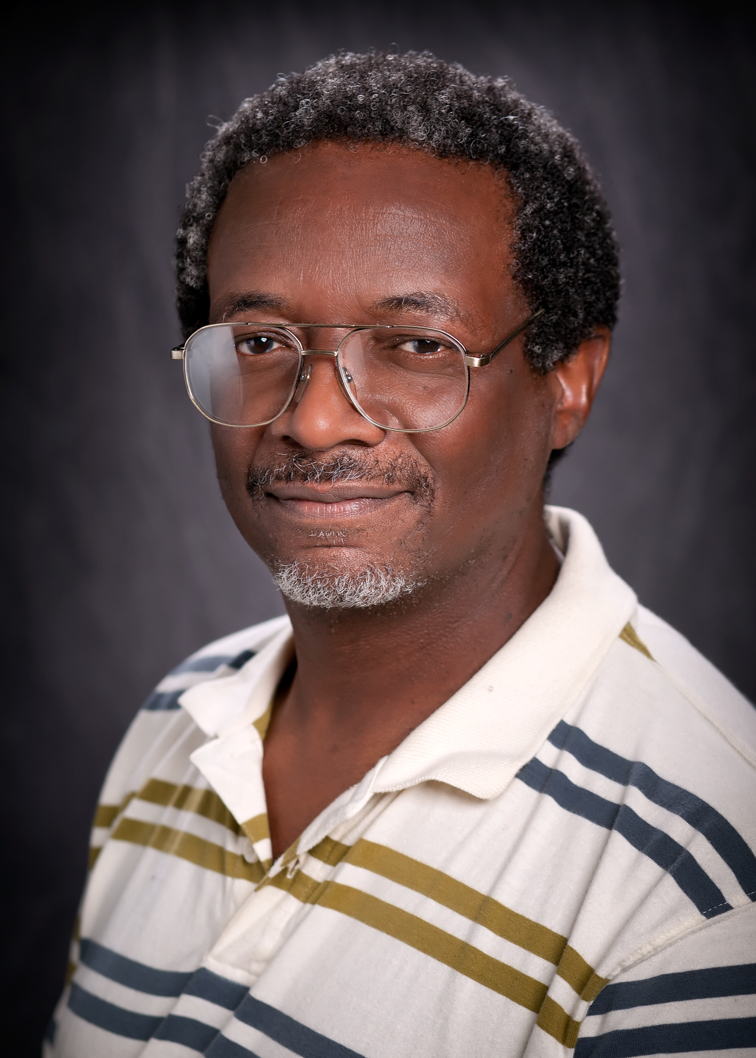
Eugene Kennedy, Louisiana State University

Eugene Kennedy is an associate professor of educational research methodology in the Department of Educational Leadership, Research, and Counseling at LSU. He teaches courses in educational measurement, statistics, and research methods. He received his Ph.D. in educational research methods from the University of South Carolina. His current research interests include educational assessment and accountability. He has been actively involved in education related evaluations for the past 20 years. He has served as principal evaluator for numerous district and state-funded projects, including Accelerated Schools Project [University of New Orleans],Quality Schools Project [Louisiana Department of Education], Louisiana Practitioner Teacher Program [Louisiana Department of Education], Baton Rouge Transitional Living Program [Casey Foundation], EBRPSS Magnet Schools Program [East Baton Rouge Parish School System]; and numerous federally-funded projects: HBCU-UP Program at South Carolina State University [NSF], LSU IGERT for Macromolecular Studies [NSF], LSU IGERT for Computational Fluid Dynamics [NSF], LSU La-STEM [NSF], CAMD REU [NSF], LSU Vigre Project [NSF], LSU HHMI Program [NSF], and LSU I-Cubed Project [NSF]. He has served as statistical consultant on numerous projects. He has served as principal psychometrics consultant for the Early Literacy Assessment Project (Picard Child Development Center) and the Primary Physical Science Psychometrics Study [East Baton Rouge Parish School System]. He serves as a member of school accountability technical advisory committees in Arkansas and South Carolina. He has also served as a member of the accountability technical advisory committee in Louisiana and was involved in several studies of which led to the current accountability model used in the State.

Richard J. Koubek, Louisiana State University

Dr. Richard J. Koubek began his tenure as Dean of the College of Engineering at LSU three years ago after more than 23 years in academia. As dean he holds the Bert S. Turner Chair in Engineering.

Prior to coming to LSU, Koubek was Professor and Head for the Harold and Inge Marcus Department of Industrial and Manufacturing Engineering at Penn State where he also held the Peter and Angel Dal Pezzo Department Head Chair. Formerly, he held the posts of Professor and Chair for the Department of Biomedical, Industrial and Human Factors Engineering, and Associate Dean for Research and Graduate Studies for the College of Engineering and Computer Science at Wright State University.

He served six years on the faculty in the School of Industrial Engineering at Purdue University and began his academic career as a faculty member in the College of Engineering and Computer Science at Wright State University.

Koubek is very well-regarded with respect to research and successful in supporting initiatives. He has authored and co-authored countless technical engineering journals, articles, book chapters and books and has given many invited presentations around the globe including Tokyo, Beijing and the United Kingdom. He has served as principal investigator and/or co-investigator on numerous research grants.

He has served as a proposal reviewer for the National Science Foundation, NASA and the Office of Naval Research. Most recently, he was appointed to serve on Tsinghua University’s Department of Industrial Engineering’s International Advisory Board. He also serves on the Board of Directors for the Industrial Modernization Center and the Consortium for Advanced Manufacturing Productivity.

Koubek’s awards include the “Click-It” Award for Innovative Use of Instructional Technology and the Pritsker Outstanding Teaching Award at Purdue University. He also served as a NEC Corporation Faculty Fellow. In 2001, he was named Department Chair of the Year at Wright State University. He is also listed in the Who’s Who in Engineering Education, the
Who’s Who in Science and Engineering and the American Society of Engineering Education.

Koubek holds bachelor’s degrees from Oral Roberts University in Tulsa, Okla., and Northeastern Illinois University in Chicago, and a master’s degree and PhD in industrial engineering from Purdue University. He and his wife, Valerie, live in St. Francisville, Louisiana.

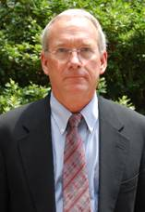
Mark A. Luker, Networking & Information Technology Research & Development

Dr. Mark A. Luker is the Associate Director of the National Coordination Office for the Networking and Information Technology Research and Development Program (NITRD). His appointment comes after joining the National Institute of Standards and Technology (NIST), Information Technology Laboratory (ITL). Prior to joining NIST, he served as a Telecommunications Policy Specialist at the National Telecommunications and Information Administration in the U.S. Department of Commerce on the Broadband Technology Opportunities Program (BTOP).
Dr. Luker has served as the Vice President (VP) of EDUCAUSE, an association of over 2,000 universities and colleges that promotes the transformation of higher education through innovative applications of information technology. As the VP, he led the Washington DC-based EDUCAUSE policy program as well as Net@EDU, a thought-leadership coalition of university Chief Information Officers (CIOs) and state network directors who work to advance national networking for both research and education.
Dr. Luker also served as the Program Director for advanced networking at the National Science Foundation and as the CIO of the University of Wisconsin-Madison campus. In this role, he was very active in several national projects including the National Learning Infrastructure Initiative and the Coalition for Networked Information.
Dr. Luker received his Ph.D. in Mathematics from the University of California, Berkeley. He served as a faculty member in computer science and as Acting Dean of Science and Engineering at the University of Minnesota, Duluth, before moving into information technology management.

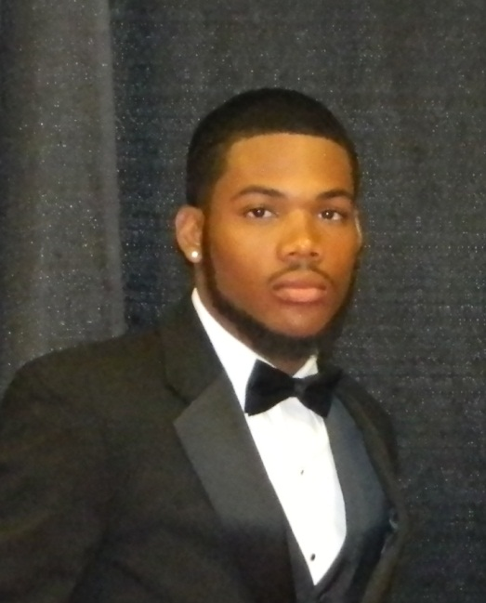
Donte McDaniel, Alabama A&M University

My name is Donte McDaniel. I am a 20 year old junior entering my senior year at Alabama A&M University studying Mathematics and Computer Science. I am a native from Dayton, OH and was born at Miami Valley Hospital on May 11, 1992. I have 2 siblings, an older brother (Darius McDaniel) and a younger sister (Destiny McDaniel). I am a proud son of Danielle & Donald McDaniel. I moved to the south in August 2010 to attend school and also to run track for Alabama A&M University. I thank God for he has done for me. Without him known of what I am doing would be possible. I am involved with a numerous amount of organizations on campus such as Computer Science club, Math Club, and Student Athletic Advisory Committee. I found my passion for track & field when I was in the 6th grade. I have been running for 9 years now. I started off running the 80 meter hurdles with USATF track & field and AAU. My favorite color is green. I am an electronic freak. I buy and sell phones. I dream big and try to pursue it. My mother is a native of Dayton, OH born on August 10, 1965. My father is a native of Cincinnati, OH born on August 13, 1961. My father has 3 siblings (2 brothers, and 1 sister). My mother has 1 sister. My grandmother has been a huge motivation in my life. My first year in college was quite overwhelming because I didn’t know what to major in. It took me a whole semester to choose computer science. I knew I had some type of spark for computers. My family would always tell me to help them fix their computer or phones. Once I started taking major classes, I became attached and it felt great. The teachers and peers that were surrounded me motivated me to become great. I strive and excel in every aspect of my life.
Michael Mislove, Tulane University

Michael Mislove is Pendergraft Herbert Buchanan Professor at Tulane University in New Orleans, LA, USA. He holds the titles of Professor of Mathematics and Professor of Computer Science, and is the chairman of the newly-formed Department of Computer Science. His research is on mathematical models of computational processes, most notably on domains and their role as such models. In recent years, the focus of his research has been on models that support probabilistic choice, their interaction with models of nondeterminism, and the applications of these models and domain-theoretic techniques in classical and quantum information.

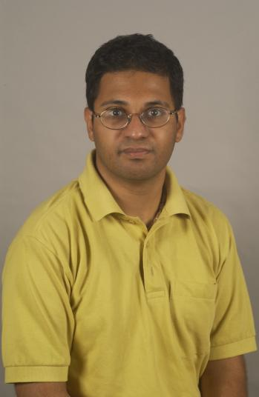
Supratik Mukhopadhyay, Louisiana State University

Dr. Supratik Mukhopadhyay is a faculty member in Computer Science at the Louisiana State University, Baton Rouge. He has been PI/co-PI of several projects funded by DARPA, RDECOM, ONR, NSF, DOE, NRL, NASA, industry, and state agencies. He has around 60 publications in reputed international journals and conferences. His research has been featured on the Discovery Channel and by media both nationally and internationally. He has delivered invited talks at Google, IBM T J Watson Research Center, Jet Propulsion Laboratory, NASA Ames Research Center, CMU Software Engineering Institute, etc.

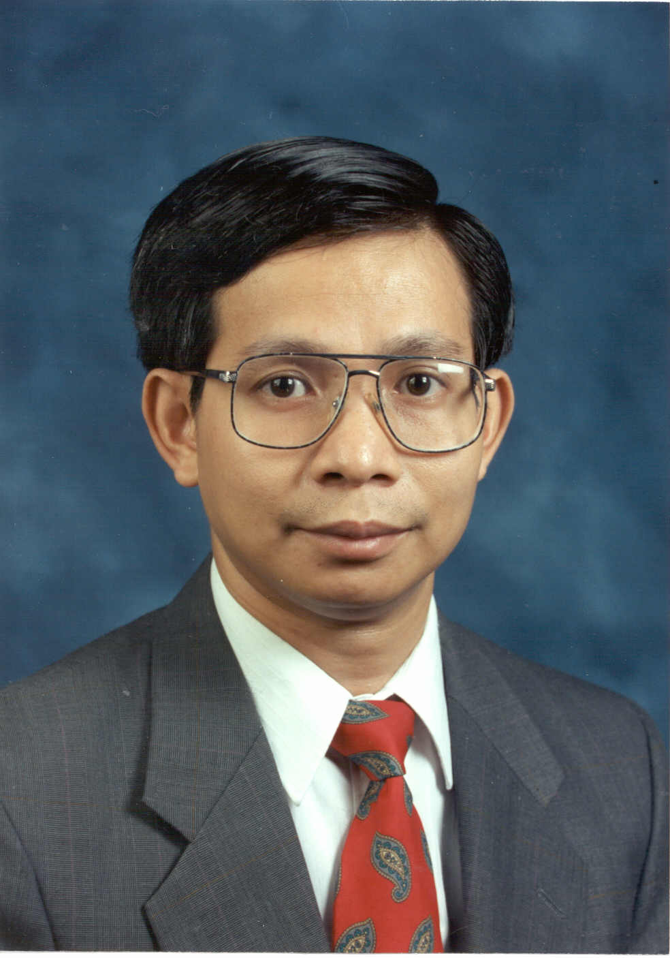
Su-Seng Pang, Louisiana State University

Dr. Su-Seng Pang received his Ph.D. degree in Mechanical Engineering from U.C. Berkeley. Currently, he is the Associate Vice Chancellor for Strategic Initiatives (since 2001) and Jack Holmes Distinguished Professor of Mechanical Engineering at Louisiana State University (LSU). Dr. Pang is a Fellow of three professional societies: American Society of Mechanical Engineers (ASME), Society of Plastics Engineers (SPE), and American Association for the Advancement of Science (AAAS). He is a recognized expert in the field of composite materials research. Dr. Pang has published over 200 journal papers/conference proceedings in the areas of composite materials and structures, pressure vessel and piping, and various joining technologies. He has been the Principal Investigator (PI)/Co-PI of 120 projects funded by NSF, NASA, Navy, Army, Air Force, Department of Energy, and various industries. His research/education projects are supporting over 250 college students per year as well as numerous high school teachers and students. Since 1996, Dr. Pang has received 34 U.S. national/regional awards in research and education, including: Presidential Award for Mentoring (at the White House); Tibbetts Award for SBIR Model of Excellence (at the White House); AAAS National Mentor Award; ACAP Distinguished Achievement Award; AACP Outstanding Achievement Award; National Faculty/Administrator Role Model Award; ASME International Board on Minorities and Women Award; Carnegie/CASE Louisiana Professor of the Year; ASEE National Minorities in Engineering Award; etc. Dr. Pang has also received many recognitions from his university, including: LSU Rainmaker Award for Research and Creative Faculty; LSU Making the Difference Award; LSU Award for Faculty Excellence; LSU Distinguished Faculty Award; LSU Alumni Association Faculty Excellence Award; LSU Undergraduate and Graduate Engineering Excellence Mentor Awards; and LSU Engineering Outstanding Faculty Service Award. Since 2008, Dr. Pang has delivered over 40 invited speeches/seminars on various education/research topics to numerous universities and organizations in Taiwan, Hong Kong, Macau, China, and United States. He was bestowed an Honorary Doctorate (Doctor of Science honoris causa) from the University of Macau, China in 2006.

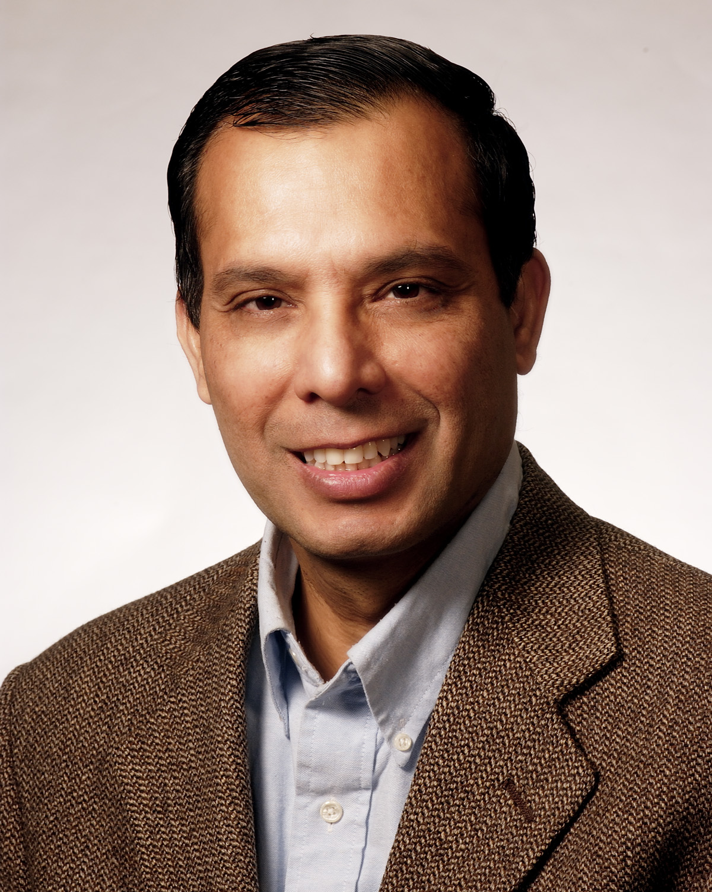
Vir Phoha, Louisiana Tech. University

Dr. Vir V. Phoha is a professor of computer science in the College of Engineering and Science at Louisiana Tech University, US. He holds the W. W. Chew Endowed Professorship at Louisiana Tech and is directing the Center for Secure Cyberspace. He has won various distinctions including: (1) Elected Fellow (2010) Society of Design and Process Sciences (SDPS); (2) ACM Distinguished Scientist, 2008; (3) IEEE Region 5 Outstanding Engineering Educator Runner-Up award, 2008; (4) Research commemoration awards at Louisiana Tech University (2002, 2006, 2007, 2008); (5) Outstanding research faculty and faculty circle of excellence award at Northeastern State University, Oklahoma, and (6) as a student was awarded the President’s Gold medal for academic distinction.

Professor Phoha has received funding from National Science Foundation, Office of Naval Research, Army Research Office, Air Force Office of Scientific Research, Air Force Research Laboratory, Louisiana Board of Regents among others. He is a PI of currently active grants of over $9.5 M and a Co-PI of grants over $ 6 M.

Professor Phoha holds an M.S. and a Ph.D. in Computer Science from Texas Tech University. He has done fundamental and applied work in anomaly detection in network systems, in particular in the detection of rare events. He has eight patent applications and many reports of inventions. He is author of over 100 publications and author/editor of five books: (1) Fundamentals of Sensor Network Programming: Applications and Technology, Wiley (2010); (2) Introduction to Contextual Processing: Theory and Applications, CRC Press (2010); (3) Internet Security Dictionary, Springer-Verlag (2002) and (4 Foundations of Wavelet Networks and Applications, CRC Press/Chapman Hall (2002), and (5) Quantitative Measure for Discrete Event Supervisory Control, Springer (2005).
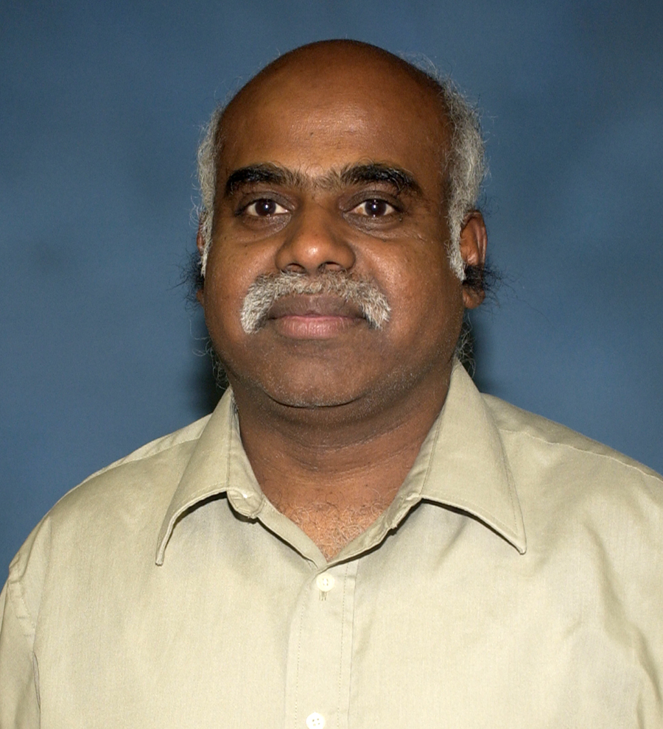
Kaliappa Ravindran, City University of New York

Kaliappa Ravindran is a Professor of Computer Science in the Grove School of Engineering at the City University of New York. Earlier, he had held faculty positions at the Kansas State University and at the Indian Institute of Science. He had also worked as a Control Systems engineer at the Indian Space Research Organization. He received Ph.D. in Computer Science from the University of British Columbia, Canada. His research interests are in the areas of service-level management of distributed networks, system-level support for information assurance, model-based software integration for embedded systems, distributed collaborative systems, and internet architectures. His recent project relationships with industries include IBM, AT&T, Philips, General Motors, and ITT. Besides industries, some of his research has been supported by grants and contracts from US federal government agencies such as the Air Force Research Laboratory, Naval Research Laboratory, and Space Missile & Defense Command.


Eric Reinsmidt, University of Tennessee at Chattanooga

Eric Reinsmidt is a recent undergraduate of the University of Tennessee at Chattanooga’s Computer Science program where he focused on software systems. He is currently working on his graduate degree with a focus in information security and assurance. Mr. Reinsmidt’s primary research interests include data mining & analysis of social media, sentiment based prediction, and security on mobile platforms.

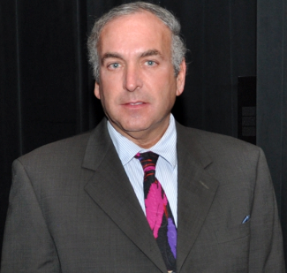
Stuart Rubin, Advanced Concepts and Applied Research Ranch

Stuart Rubin is a Senior Scientist in the Advanced Concepts and Applied Research Branch of SSC Pacific, San Diego, CA. He is the author or co-author of 254 publications and over 23 issued patents assigned to the Navy. He is the inventor of the KASER knowledge amplifier, which was first applied to the F-16 radar fault-diagnostic system with other applications pending. His focus areas of interest include computational creativity and knowledge-discovery systems – emphasizing heuristic, evolutionary, fuzzy, and randomization-based methodologies. Dr. Rubin is a Fellow of the Society for Information Reuse and Integration (SIRI).

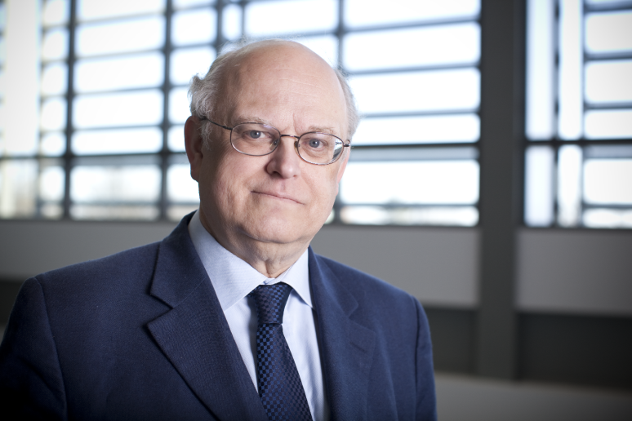
Thomas Sterling, CREST Executive Associate Director

Thomas Sterling is Professor of Informatics and Computing at Indiana University. He serves as the Executive Associate Director of CREST and as its Chief Scientist. Since receiving his Ph.D from MIT as a Hertz Fellow in 1984, Dr. Sterling has conducted research in parallel computing systems in industry, academia, and government centers. He is most widely known for his pioneering work in commodity cluster computing as leader of the Beowulf Project for which he and colleagues were awarded the Gordon Bell Prize. Professor Sterling currently leads a team of researchers at IU to derive the advanced ParalleX execution model and develop a proof-of-concept reference implementation to enable a new generation of extreme scale computing systems and applications. He is the co-author of six books and holds six patents.

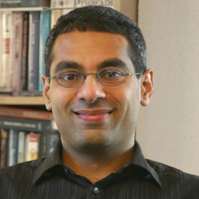
Niranjan Suri, Florida Institute for Human and Machine Cognition

Niranjan Suri is a Research Scientist at the Florida Institute for Human and Machine Cognition (IHMC) in Pensacola, FL. He is also a Visiting Scientist at the U.S. Army Research Laboratory in Adelphi, MD. He received his Ph.D. in Computer Science from Lancaster University, England, ad his M.Sc. and B.Sc. in Computer Science from the University of West Florida, Pensacola, FL.

Niranjan's current research activity is focused on the notion of Agile Computing - which supports the opportunistic discovery and exploitation of resources in highly dynamic networked environments such as the tactical networking domain. As part of this area of research, Niranjan has led the development of the Mockets communications middleware, the Group Manager grouping and discovery component, the DisService peer-to-peer dissemination service, the DSPro proactive information dissemination service, and the NetProxy component for integration with legacy applications.

He also works on Process Integrated Mechanisms - a novel approach to coordinating the behavior of multiple robotic, satellite, and human platforms. As part of PIMs, he focuses on reducing the complexity of developing solutions for coordination, improving the robustness and predictability of distributed systems, and to improve bandwidth utilization by moving processing to data.

Niranjan's other research interests include information management, especially the notion of federated information systems, disaster recovery, and distributed systems in general. He has also worked on networking and communications protocols, virtual machines, energy-aware computing, and software agents.

He co-organized the Knowledge Systems for Coalition Operations conference in 2012 and the Agents, Interactions, Mobility, and Systems (AIMS) track at the ACM Symposium on Applied Computing from 2002 to 2006. He has taught Undergraduate and Graduate courses in Computer Science at the University of West Florida for 10 years. He has been a principal investigator of numerous research projects sponsored by the U.S. Army Research Laboratory (ARL), the U.S. Air Force Research Laboratory (AFRL), the Defense Advanced Research Projects Agency (DARPA), the Office of Naval Research (ONR), and the National Science Foundation (NSF). He has authored or co-authored over 100 papers, has been on the technical program committees of several international conferences, and has been a reviewer for NSF as well as several international journals.

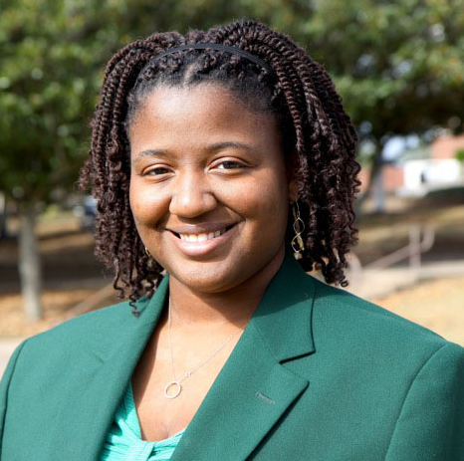
Olivia Wilson, Florida A&M University

Olivia Wilson is currently a senior in Computer and Information Sciences at Florida A&M University, majoring in Information Technology. A native of Tallahassee, Olivia is a strong advocate of increasing diversity in computing, currently serving as Evaluation Assistant for the FAMU Chapter of the STARS Alliance, an NSF Broadening Participation in Computing (BPC) project. Additionally, Olivia is heavily involved in outreach, recruiting and mentoring projects at FAMU. Upon graduation, Olivia plans to pursue a graduate degree in computer science and future her research experiences in the field.

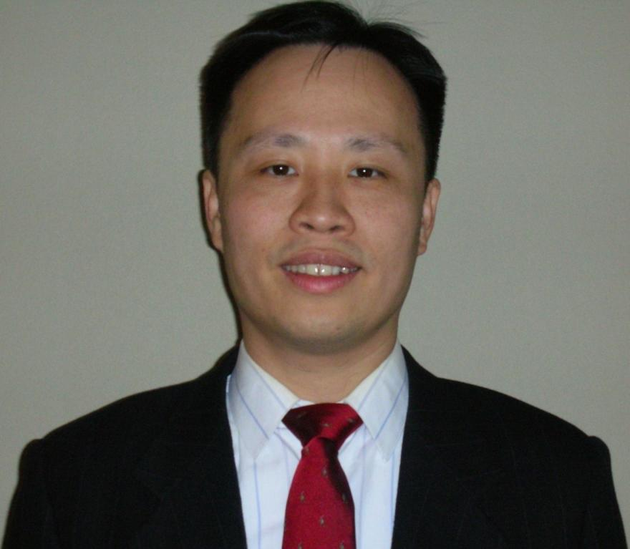
Hsiao-Chun Wu, Louisiana State University

Dr. Hsiao-Chun Wu received a B. S. E. E. degree from National Cheng Kung University, Taiwan, in 1990, and the M. S. and Ph. D. degrees in electrical and computer engineering from University of Florida, Gainesville, in 1993 and 1999 respectively. From March 1999 to January 2001, he had worked for Motorola Personal Communications Sector Research Labs as a Senior Electrical Engineer. Since January 2001, he has joined the faculty in Department of Electrical and Computer Engineering, Louisiana State University, Baton Rouge, Louisiana, USA. From July to August 2007, Dr. Wu had been a visiting assistant professor at Television and Networks Transmission Group, Communications Research Centre, Ottawa, Canada. From August to December 2008, he was a visiting associate professor at Department of Electrical Engineering, Stanford University, California, USA.

Dr. Wu has published more than 160 peer-refereed technical journal and conference articles in electrical and computer engineering. His research interests include the areas of wireless communications and signal processing. Dr. Wu is an IEEE Senior Member and an IEEE Distinguished Lecturer. He currently serves as an Associate Editor for IEEE Transactions on Broadcasting, IEEE Signal Processing Letters, IEEE Communications Magazine, International Journal of Computers and Electrical Engineering, Journal of Information Processing Systems, Physical Communication, and Journal of the Franklin Institute. He used to serve as an Associate Editor for IEEE Transactions on Vehicular Technology. He has also served for numerous textbooks, IEEE/ACM conferences and journals as the technical committee, symposium chair, track chair, or the reviewer in signal processing, communications, circuits and computers.


Li Yang, University of Tennessee at Chattanooga

Computer Science and Engineering at University of Tennessee at Chattanooga (UTC). She is also the Director of InfoSec Center, a National Center of Academic Excellence – Information Assurance Education (CAE-IAE). Her research interests include mobile security, network and information security, cryptography, and sentiment mining. She actively involves students into research. She authored papers on these areas in refereed journal, conferences and symposiums. She teaches a broad scope of courses in Computer Science including programming, information security, networking, database and operating system.

Participant CVs (in Alphabetical Order)

Jason Timothy Black
Associate Professor
Computer and Information Sciences
Florida A&M University
jblack@cis.famu.edu

Education
Ph.D. Computer and Information Sciences, Florida State University, December 2004.
M.S. Computer Science, The Georgia Institute of Technology, December 1992.
B.S. Computer and Information Systems, Florida A&M University, May 1991.

Professional Employment
08/07 – present: Associate Professor, Florida A&M University, Computer and
Information Sciences, Tallahassee, FL

08/02 – present: Assistant Professor, Florida A&M University, Computer
Information Sciences, Tallahassee, Florida.

08/00 – 08/02: Instructor, Florida A&M University, Computer Information
Sciences, Tallahassee, Florida.

01/95 – 08/00: Science Academic Coordinator, Florida-Georgia Alliance for
Minority Participation in Science, Engineering and Mathematics (SEM) Scholarship Program, Florida A&M University Chapter, Tallahassee, Florida; a $300,000/year grant program sponsored by National Science Foundation (NSF).

08/93 – 12/94: Adjunct Instructor, Florida A&M University, Computer
Information Systems, Tallahassee, Florida.

03/93 – 08/93: Computer Programmer I, Florida Department of Highway Safety
and Motor Vehicles, Tallahassee, Florida.

Research Areas
- Mobile Computing
- Gaming for Learning (Educational Games)
- Computer Supported Collaborative Learning (CSCL)
- Computer Supported Collaborative Work (CSCW)
- Educational Technology
- Human-Computer Interaction (HCI)
- Broadening Participation in Computing (BPC)

Professional Activities
- FAMU Representative, National Council on Undergraduate Research (CUR), May 2010 – Present
- FAMU Representative, National Conference on Women in IT (NCWIT), Fall 2009 – Present
- FAMU Representative, Tallahassee Technology Alliance (TalTech), Spring 2011 – Present
- Reviewer: NSF Panel Review – GK-12 Graduate Students Teaching in K-12 Education Grant Submission Process, July 2005, Arlington, VA
- Attendee: National Conference of Women in IT (NCWIT) / NSF Broadening Participation in Computing Joint Conference, Boulder, CO, May 2007
- Member, Editorial Committee, 3rd Indian International Conference on Artificial Intelligence (IICAI-07).
- Member, Florida A&M University Quality Enhancement Protocol (QEP) Committee, Fall 2006 – Present
- Member, Planning Committee, Florida-Georgia Louis Stokes Alliance for Minority Participation (FG-LSAMP) Expo (2004-2008)

RESEARCH
Grants Funded:
- Co-Principal Investigator, The STARS Alliance – A Southeastern Partnership for Broadening Participation in Computing, partnering with Teresa Dahlberg (PI) at UNC-Charlotte, funded by the National Science Foundation, 1/06 – 12/12, over $5,000,000 (FAMU is sub-contractor)
- Principal Investigator, AAWCS– African-American Women in Computer Science, with Dr. Edward L. Jones, Chair, CIS. Funded by the National Science Foundation, 7/1/08 – 6/30/12, $552,000
- Co-Principal Investigator, ITEST – The TRI-Regional Information Technology Project (TRI-IT), funded by National Science Foundation. Partnering with Florida State College at Jacksonville (FSCJ) and Seminole State College (SSC). 01/09 – 12/11, $1,500,000 (FAMU is sub-contractor).
- CRI: Development of an Ambient Computer Laboratory, with Clement Allen, funded by the National Science Foundation, 5/06 – 5/08, $249.840
- FAMU Faculty Pilot Research Program, with Dr. John Chambers, Dept. of Psychology, Florida A&M University, funded by Florida A&M University, 9/04-12/05, $2,400.

PUBLICATIONS
Books / Book Chapters:

Black, J., Hawkes, LW. (2011, 2007). “Proposing a Children’s Mobile Collaborative Reading Tool”. Chapter Submission for Handbook of Research on User Interface Design and Evaluation for Mobile Technology, Lumsden, Jo., National Research Council of Canada, New Brunswick, Canada, 2007 (Currently being re-printed).
Refereed Journal Publications:

Black, J., Hawkes, LW. (2007). Making the Case for Collaborative Mobile Learning for Reading Comprehension on Handheld Computers. In International Journal of Technology, Knowledge and Society, Cambridge, UK, 2007 (Currently being printed).

Allen, C., Black, J., Ayodele, M., and Jones, E. (2007). The AyoBoard: An Environment for Storyboarding Ambient Environments. In ISAST Transactions on Computers and Software Engineering, 2007 (Currently being printed).
Refereed Conference Proceedings:

Black, J, Hawkes, L, (2006). A Prototype Interface for Collaborative Mobile Learning. In ACM Proceedings of International Wireless Communications and Mobile Computing Conference (IWCMC ’06), Vancouver, British Columbia. July 2-6, 2006, pp. 1277-1282.

Black, J, Hawkes, L, Jean-Pierre, J, Johnson, I & Lee, M. (2004). A Paper Prototype Study of the Interface for a Children’s Collaborative Handheld Learning Application. In Proceedings of Mobile Human-Computer Interaction MobileHCI 2004, Glasgow, Scotland. September 13-16, 2004, pp. 305-309.

Graduate Masters Thesis Directed

Sabrina Fontaine, M.S., Software Engineering, Fall, 2010; Thesis: MASDA: A Methodology for Addressing Software Develoment in Academia.

JeRone Gant, M.S. Software Engineering, Spring 2010; Thesis: Mobile-Enhanced Context-Aware AyoBoard (MECCA).

Kahil Wright, M.S., Fall 2007, Thesis: Mobile Infrastructure for Facilitating Speech Recognition in a Collaborative Programming Environment.

Melissa Clark, M.S. Fall 2006, Thesis: HIPPE: A User Interface Architecture for Pair Programming on Handheld Devices.

LeAndrew Davis, M.S., Software Engineering, Graduation: Summer 2012

Nicolas C. Diogo, Ph.D.
Office: 305-623-1401, nicolas.diogo@fmuniv.edu

- Education
Ph.D.: Educational Computing Technology
Barry University, 2001
M.S.: Educational Computing Technology
Barry University, 1999
B.S. : Biological Sciences
National University of Benin (West Africa), 1991

- Academic experience

Florida Memorial University,
Department of Computer Sciences, Mathematics, and Technology
- Assistant Professor of Computer Information Systems (2009-Present)
- Adjunct Professor (2001-2009)
- Technology
Miami Dade County Public Schools
- Mathematics and Science Instructor (1994-2009)
- Chair Math and Science Departments and coach teachers to successfully infuse technology into the math and science curriculum. (1994-2009)
- Direct the Math and Science Departments in writing the School Improvement Plan.

- Non-academic experience

Alpha Import: 1997 to 2000
Computer Technician, Assemble computers to be exported to West Africa for Sale; Part time

- Certifications or professional registrations

CERTIFIED INTERNET WEBMASTER: Web Site Manager, Administrator,
E-Commerce Designer, Security Analyst, Database Specialist CIW, 2009 (USA)
CERTIFICATE : A+ CompTIA, 2010 (USA)
ADOBE CERTIFIED EXPERT (ACE), 2010 (USA)
Dreamweaver & Flash CS4
CERTIFICATE : INTERNATIONAL COMMERCE – TRANSIT
C.E.E.T. Libreville, Rep of Gabon (Central Africa)
CERTIFICATE : INTERNATIONAL COMMERCE – MANAGEMENT
CIFOR LIEGE, Belgium (Europe)
CERTIFICATE : TRANSLATION : French – English, English – French
Ghana Institute of Languages (West Africa)
FLORIDA TEACHING CERTIFICATION: Mathematics 5-9, 6-12; Middle Grade Science 5-9, Biology 6-12

- Current membership in professional organizations

ISTE: International Society for Technology in Education
FSTE: Florida Society for Technology in Education

- Honors and awards
- Teacher of the year
- Most Valuable Teacher

- Service activities

Active member of:
- Faculty Senate
- Quality Enhancement Plan
- Curriculum and Instruction
Florida Teacher Certification Test writer (Pearson)

- Briefly list the most recent professional development activities

Sustainable Assessment Processes (ABET; Oct 2010)
Quality Enhancement Plan (QEP) Implementation Process

Hassan Elhalaby
92-43 Gettysburg St., Bellerose, NY 11426
Cell: [718-808-2003] Home: [718-343-3237]
Email: [elhalabyh@gmail.com]

Objective
To utilize my skills in solving everyday computer hardware & software related problems in various professional environments.

Education
The City College of New York -- New York, New York
Bachelor of Science: Computer Science February 2013

Newtown High School -- Elmhurst, New York
Advanced Regents Diploma: Pre-Engineering Program June 2006

Experience
NSF Internship, Cyber-Infrastructure Protection
Louisiana State University, Louisiana — (April 2013-July 2013)
Responsibilities
● Attend cyber-infrastructure protection workshops given by professionals.
● Research network simulation tools.
● Research transmission over congested networks.
● Present research to various groups over internship period.
In-Home PC Technician, Self Employed
Various Locations, New York — (2008-Present)
Responsibilities
● Maintain & repair computer systems for private clients at their residence.
● Setup new computer stations.
● Setup home and office networks.
● Install, maintain, & repair computer related electronics.
● Install & troubleshoot home theatre systems.
● Provide over the phone assistance.
Computer Lab Assistant, The City College of New York
New York, New York — (2012-2013)
Responsibilities
● Assisted students using the Linux and Windows lab computers.
● Assisted students with their homework and projects.

Human Resources Office Assistant, Eihab Human Services
Springfield Gardens, New York — (2007-2008)
Responsibilities
● Assisted the office with technology related problems.
● Performed various secretarial tasks within the Human Resources Department.

Computer Lab Assistant, Newtown High School
Elmhurst, New York — (2004-2006)
Responsibilities
● Assisted students using the lab.
● Maintain & troubleshoot computers in the lab.

Skills
● Maintain, diagnose & troubleshoot computer hardware & software.
● Troubleshoot home theatre installations and equipment.
● Design & maintain creative websites & web-applications.
● Professional software testing.
● Professional understanding of networking.
● Operating Systems:
○ Microsoft Windows
○ Apple Macintosh
○ Linux
■ Ubuntu
■ Mint
■ CentOS
● Programming Languages & Frameworks:
○ C++
○ Python
○ JavaScript
○ HTML
○ CSS
○ Django Framework
● Software:
○ Office & Productivity:
■ Microsoft Office
■ Apple iWorks
■ Apache Openoffice, LibreOffice
○ Design Software:
■ Adobe Creative Suites
○ Programming IDE’s
■ Microsoft Visual Studio
■ Apple Xcode
■ Eclipse
● Mobile Application Design
○ Android

References
Dr. Jie Wei
Professor, The City College of New York - Senior Design Project Mentor
212-650-5604

Dr. Kaliappa Ravindran
Professor, The City College of New York - Computer Networks & Operating Systems Professor
212-650-6218

Meaghan Janedis
CEO, Legacy Sport - Provided Computer Related Tasks
917-608-6510

Nikita Jaikaran
Lab Manager, The City College of New York
212-650-6182
Dr. Yujian Fu

Associate Professor, Department of EE&CS

Contact Information
Dr. A. Bond Bld, Room 333
Department of Electrical Engineering & Computer Science
School of Engineering, Technology & Physical Sciences
Alabama A&M University
4900 Meridian Street, Normal AL 35762
Tel: (256) 372-8461
Fax: (256) 372-5578
Email: yujian.fu@aamu.edu

Research Interests
Software engineering. Specialized areas of interest: verification and validation, real time embedded software design and quality assurance, software testing, formal methods, runtime verification, software architecture, service oriented architecture (SOA), software evolution.

Journal Papers, Book Chapters, Refereed Conference/Workshop Papers (partial list)
[1] Yujian Fu. Stability Analysis of Biped Walking Robot. Journal of Software Engineering for Robots, 2013.
[2] Yujian Fu, F. Li. A Formal Framework of Electronic Smart Grid. International Journal of Secure Software Engineering, 2013 (under review)
[3] Yujian Fu, L. Yan, J. Kulick, S. Drager. Formal Modeling and Verification of Security Properties of Handel C Programs. International Journal of Secure Software Engineering, 2012
[4] Yujian Fu, S. Li. A Hierarchical Graph-based Testing of UML2 Sequence Diagram. International Journal of Computer and Network Security, Vol 2, No. 9, September 2010
[5] Yujian Fu, S. Li, X. He, Z. Dong and P. Bording. A Model Driven Approach for Runtime Assurance of Software Architectures. International Journal of Computer and Network Security, Vol 2, No. 5, 2010
[6] S. Li, S. King, Yujian Fu. Factors that Inuence Learner-Content Interaction in the Online Top-Down Modeling Model Environment. International Journal of Computer and Network Security, Vol 2, No. 9, 2010
[7] Yujian Fu, Z. Dong, and X. He. A Translator of Software Architecture Design from SAM to Java. International journal of Software Engineering and Knowledge Engineering. Vol. 17 No. 6, 2007.
[8] Yujian Fu, Z. Dong, H. Yu, and X. He. Towards Evolution Analysis of Software Architecture Description. Special Issue of International Journal of Software Architecture, 2007.
[9] S. Li and A. Leh and Yujian Fu and X. Xhao. Learners' Preferences in Using Online Learning Resources. Quarterly Review of Distance Learning, Vol. 10, No. 3, 2009, pages 299-303.
[10] S. Li and S. King and E. Jones and Yujian Fu and X. Xhao. Integrating Multimedia into Ag Education Instruction. North American Colleges and Teachers of Agriculture (NACTA) Journal, Vol. 52, No. 3, June 2008.
[11] Yujian Fu, Z. Dong, and X. He. Architecture Centered Integrated Verification. Modern Software Engineering Concepts and Practices: Advanced Approaches, Edited by Ali H. Dogru, Veli Bicer. IGI Global Dissemintor of Knowledge (In Press).
[12] Yujian Fu, Z. Dong, and X. He. Towards Rewriting Semantics of Software Architecture Speci_cation. Petri Nets, Edited by Vedran Kordic, ISBN 978-953-307-047-6. I-Tech Education and Publishing.
[13] Yujian Fu, Z. Dong, and X. He. Formalizing UML Architecture Description. Petri Net, Theory and Application, Edited by Vedran Kordic, ISBN 978-3-902613-12-7. I-Tech Education and Publishing.
[14] P. Bhattacharya, M. Guo, L. Tao, Yujian Fu, and Kai Qian. A Collaborative Interactive Cyber-learning Platform for Anywhere Anytime Java Programming Learning. The 11th IEEE International Conference on Advanced Learning Technologies (ICALT’11), Athens, GA, Jul 6-8, 2011. (Accepted)
[15] S. Jasti, Yujian Fu, and P. Koneru. Modeling and Analyzing Web-based Information Systems. The International Conference on Software Engineering and Research Practice (SERP 2010), Las Vegas NV, Jul 12-15, 2010.
[16] Yujian Fu, J. Ding, P. Bording. An Approach for Modeling and Analyzing Crosscutting Concerns. The 5th International Conference on Service Operations, Logistics and Informatics (SOLI 2009), Chicago, IL Jul 22-24, 2009.
[17] Yujian Fu, Z. Dong, J. Ding, X. He. Modular Verification of Software Architecture Model. The International Conference on Software Engineering and Research Practice (SERP 2009), Las Vegas Jul 12-16, 2009.
[18] Yujian Fu, Z. Dong, J. Ding, X. He. Towards Rewriting Semantics of A Software Architecture Model. The 8th International Conference of Quality Software, Oxford UK, Aug 12-13 2008.
[19] G. Argote-Garcia, P. Clarke, X. He, Yujian Fu. A Formal Approach for Translating a SAM Architecture to PROMELA. In Proceedings of SEKE’08: Nineteenth International Conference on Software Engineering and Knowledge Engineering. San Francisco, USA, July 1 – July 4, 2008.
[20] S. Li and S. King and E. Jones and Yujian Fu and X. Xhao and D. Price. Multimedia Talents Among African American Students. In Proceedings of The 16th Annual Conference of National Association of African American Studies. Baton Rouge, Louisiana, USA. February 11-16, 2008.
[21] Yujian Fu, Z. Dong, G. Argote-Garcia, Y. Shi, and X. He. A Method of Validating Translation from SAM to Java. In Proceedings of SEKE’07: Nineteenth International Conference on Software Engineering and Knowledge Engineering. Boston, USA, July 9 – July 11, 2007.
[22] Yujian Fu, Z. Dong, and X. He. A Method for Realizing Software Architecture Design. In Proceedings of QSIC’06: Sixth International Conference on Quality Software. Beijing, China, October 26 – 28, 2006.
[23] Yujian Fu, Z. Dong, and X. He. Validating and Automating Composition of Web Services. In Proceedings of ICWE’06: Sixth International Conference on Web Engineering, pages 217 – 224, Palo Alto, CA, USA, July 10-14, 2006. (Best Paper Session)
[24] Yujian Fu, Z. Dong, and X. He. An Approach to Web Services Oriented Modeling and Validation. In Proceedings of ICSE’06 workshop: The 2006 International Workshop on Service Oriented Software Engineering, Shanghai, China, May 27-28, 2006.
[25] Z. Dong, Yujian Fu, and X. He. A Framework for Component-based System Modeling. In Proceedings of SEKE’06: The eighth International Conference on Software Engineering and Knowledge Engineering, pages 290 – 295, San Francisco Bay, CA, USA, July 5-7, 2006.
[26] Z. Dong, Yujian Fu, and X. He. An Integrated Runtime Monitoring Framework for Software Architecture Model Veri_cation. In Proceedings of The 9th IASTED International Conference on Software Engineering and Applications, Phoenix, AZ, USA, pages 106 – 111, November 14-16, 2005.
[27] Yujian Fu, Z. Dong, and X. He. Formalizing and Validating UML Architecture Description of Web Systems. In Proceedings of ICWE’06 workshop: Model-Driven Web Engineering (MDWE’06), Palo Alto, CA, USA, July 10-14, 2006.
[28] Yujian Fu, Z. Dong, and X. He. An Approach to Validation of Software Architecture Model. In Proceedings of APSEC’05: twelfth Asia-Pacific Software Engineering Conference (APSEC), December 15-17, 2005, TaiPei, Taiwan, China.
[29] Yujian Fu, Z. Dong, and X. He. A Methodology of Automated Realization of a Software Architecture Design. In Proceedings of SEKE’05: the 17th International Conference on Software Engineering and Knowledge Engineering, pages 412–417. Taipei, Taiwan, July 14 – 16, 2005.
[30] Z. Dong, Yujian Fu, and X. He. Automated Runtime Validation of Software Architecture Design. In Proceedings of 2nd International Conference on Distributed Computing & Internet Technology (ICDCIT 2005), Lecture Notes in Computer Science, Vol. 3816, pages 446 – 457, Bhubaneswar, India, December 22-24, 2005. (Best paper nomination)
[31] Z. Dong, Yujian Fu, and X. He. UML Consistency Checking Through Transformation based Petri Net Framework. The workshop of Consistency in Model Driven Engineering (CoMoDE), in conjunction with European Conference on Model Driven Architecture, Nuremberg, Germany. November 7 – 10th, 2005.
[32] Z. Dong, Yujian Fu, and X. He. Deriving Hierarchical Predicate/Transition Nets from Statechart Diagrams. In proceedings of the 15th International Conference on Software Engineering and Knowledge Engineering, pages 150 – 157. San Francisco, CA, U.S.A. July 1 – 3, 2003.
[33] Yujian Fu and X. Yao. Computer Assisted Diagnosis of Hypertension. In proceedings of the Symposium of the Chinese Association of Geriatric Research. Xian, Shanxi, China. 1999.

Projects
Current & past funded projects are:
- “Collaborative Project: Integrating Testing into CS/IT Courses Supported by WReSTT”, NSF, 2013 to 2015.
- “Modeling & Verification of Humanoid Robots”, Air Force Research Lab, 2012
- “Architecture Driven Formal Analysis of Embedded System Evolution”, Title III office, Alabama A&M University, 2009 - 2010.

Professional Services
[1] Dynamic Analysis of Software Architecture Model, Department of Computer Science, Florida A&M University, Feb 4, 2009 (Invited Talk)
[2] Software Design Quality Assurance, Department of Computer Science, University of Alabama At Nov 9, 2007 (Invited Talk)
[3] Student Advising
[4] Reviewer for 15 journals and conferences.

Affiliations
Member of ACM
Member of IEEE Computer Society
Member of ASEE

Treston Hall
halltreston@yahoo.com
Education
2010- Current
Florida Memorial University –Miami Gardens, Florida
Major: Computer Science
GPA 3.4
2006-2010
Deerfield Beach High School
High School Diploma
Work Experience
Touch of Class
- Detailing Assistant
Florida Memorial University
- Work Study Student
Achievements
- Upsilon Pi Epsilon Honor Society
Activities
- Coordinate Intermural Activities at Florida Memorial University
- High School Football
Skills
- Microsoft Office
- Java Programming

H. DWAYNE JERRO, Ph.D.
Professor

Southern University and A&M College Phone: (225) 771-3580
Department of Mechanical Engineering Fax: (225) 771-4877
P.O. Box 9969, Baton Rouge, LA 70813 Email: Dwayne_Jerro@subr.edu

EDUCATION
Ph.D. Mechanical Engineering, Louisiana State University, 1998
Certificate Inst. for Mechanics & Materials Summer School, Univ. California, San Diego, 1994
B.S. Mechanical Engineering, Southern University, Baton Rouge, 1991

PROFESSIONAL EXPERIENCE
8/11 – Pres Professor, Mechanical Engineering Department, Southern University
8/06 – 8/11 Associate Professor, Mechanical Engineering Department, Southern University
8/02 – 5/07 Assistant Professor (Joint Faculty Appointment with Southern University), Mechanical Engineering Department, Louisiana State University (LSU)
8/02 – 8/06 Assistant Professor (Joint Faculty Appointment with LSU), Mechanical Engineering Department, Southern University
9/99 – 8/02 Assistant Professor, Mechanical Engineering, Louisiana Tech University
1/99 – 8/99 Research Asst. Professor, Center for Energy & Environ. Studies, Southern U.

HONORS/DISTINCTIONS
2009-10 Southern University - Mechanical Engineering Outstanding Faculty Member
2008-09 Southern University - Mechanical Engineering Favorite Faculty Award
2004 Southern University STEM - Young Faculty Award (Hall of Fame Inductee)
2000-01 Louisiana Tech Mechanical Engineering's Golden Shaft Award
2000 Louisiana Tech Coll. of Engr. & Sci. Research Coll. Award (Co-Recipient)
1999 Grant Parish (Louisiana) School Board Outstanding Citizen Resolution
1995 “Best Paper Award” for the ASME/ETCE Conference’s Materials & Design Technology Symposium
1992-95 Louisiana Board of Regents Dean’s Fellowship

LIST OF RECENT PUBLICATIONS
- Babu, S., N. Vellore, A. Raghavamenon, H. D. Jerro, S. Yang, R. Uppu, “Molecular Docking of Bisphenol A and its Nitrated and Chlorinated Metabolites Onto Estrogen-Related Receptor-Gamma,” Free Radical Biology and Medicine, Vol. 51, Supplement, Nov. 1, p. S141 (2011).
- Jana, A., K. Sekeroglu, H. D. Jerro, P. Mensah, S. Ibekwe, S. Kodiyalam, “ME Laboratories with Mechatronics Component,” Proceedings of the 2011 ASEE Gulf-Southwest Annual Conference, Session F2C-2, Houston University, Houston, Texas, March 9-11 (2011).
- Ji, G., Z. Ouyang, G. Li, H. D. Jerro, S. S. Pang, “Effect of Bondline Thickness on Interfacial Fracture of Laminated Composite Materials,” The Proceeding of the ASME 2010 Pressure Vessel and Piping (PVP) Conference, Paper #PVP2010-25714, Session 1.1.H, Bellevue, Washington, July 18-22 (2010).
- Jana, A., K. Sekeroglu, H. D. Jerro, P. Mensah, S. Ibekwe, S. Kodiyalam, “Enhancement of ME Laboratories with Interdisciplinary Emerging Technologies,” Proceedings of the 2010 ASEE Gulf-Southwest Annual Conference, McNeese State University, LA, March 24-26 (2010).
- Maharsia, R. R., H. D. Jerro, “Enhancing tensile strength and toughness in syntactic foams through nanoclay reinforcement,” Material Science and Engineering A, Vols. 454-455, pp. 416-422 (2007).
- Maharsia, R. R., N. Gupta, H. D. Jerro, “Investigation of flexural strength properties of rubber and nanoclay reinforced hybrid syntactic foams,” Material Science and Engineering A, Vol. 417, Issues 1-2, pp. 249-258 (2006).
- Li, X., M. A. Stubblefield, G. Li, H. D. Jerro, “Fusion and Visualization of 3D Image Elevation Data in Computer Automated Virtual Environment (CAVE), Proceedings of the Earth and Space 2006: Engineering, Construction, and Operations in Challenging Environments Conference of the American Society of Civil Engineers (ASCE), League City / Houston, TX, March 5-8 (2006).
- Gupta, N., E. Woldesenbet, and H. D. Jerro, "Effect of Microballoon Radius Ratio on Syntactic Foam Core Sandwich Composites," Journal of Sandwich Structures and Composites, Vol. 7, No. 2, pp. 95-111 (2005).
- Gupta, N., R. R. Maharsia, H. D. Jerro, “Enhancement of Energy Absorption Characteristics of Hollow Glass Particle Filled Composites by Rubber Addition,” Material Science and Engineering A, Vol. 395, Issues 1-2, pp. 233-240 (2005).
- Jerro, H. D., C. Huang, N. Gupta, P. Mensah, A. Aripirala, “Implementation of an Interactive Concept Mapping Technique in an Engineering Courses,” Proceedings of the ASEE Gulf-Southwest Section 2004 Conference, Lubbock, Texas, March 10-12 (2004).
- U.S. Patent No. 5289794 – March 1994, Magnetically Aligned Transmission Shift Indicator, (H. D. Jerro, J. L. Kohler, S.G. Skiver, T. J. Candy, D. F. Wildfong, and M. D. Murphy)

SYNERGISTIC ACTIVITIES
- “The Enhancement of ME (Mechanical Engineering) Laboratories,” Louisiana Board of Regents, $73,387, Southern University (SU) PI: A. Jana, Co-PIs: H. D. Jerro, S. Ibekwe, P. Mensah, 06/01/2009 to 05/30/2012.
- “The LONI Institute: Advancing Biology, Materials, and Computational Sciences for Research, Education, and Economic Development,” Louisiana Board of Regents, $7,000,000, LSU PI: E. Seidel; Southern University (SU) PI: H.P. Mohamadian, SU Co-PIs: E. Khosravi, H. D. Jerro, Other Institutions: Louisiana Tech University, University of New Orleans, Tulane University, University of Louisiana-Lafayette, 07/01/2007 to 06/30/2012.
- “Smart Adhesively Bonded High-Performance Joint for Composite Structures” NASA EPSCoR/Louisana Board of Regents, $2,007,000, PI: J. Wefel; LSU-PI: G. Li, LSU Co-Is: S.S. Pang, M. Wahab, K. Lian; Southern University (SU)-PI: M. Stubblefield, SU Co-Is: S. Ibekwe, H. D. Jerro, 10/01/2007 to 09/30/2011.
- “Scholarships Creating Opportunities for Retention in Engineering (SCPORE),” National Science Foundation, $500,000, PI: K.E. Crosby, Co-PIs: E.R. Blevins, F. Lacy, H. D. Jerro, 01/15/2007 to 12/31/2010.
- “Collaborative Project: Faculty Development -- Multi University Research and Training in Information Assurance and Computer Security,” National Science Foundation, $407,533, (LSU): PI: S.S. Iyengar; Co-PIs: S.S. Pang, P. Chen, R. Kannan; (Louisiana Tech): V. Phoha; (Southern University): M.A. Stubblefield, G. Li, H. D. Jerro, 01/01/2007 to 12/31/2008.

GRADUATE/POSTGRADUATE ADVISEES
Rahul Maharsia, M.S. (Louisiana Tech) & PhD. (LSU), Alfred Maldonado, M.S. (Louisiana Tech), G. Garrick, M.S. (LSU), Gefu Ji, M.S. (SU), Sushma Manjunath, M.S. (LSU); Sreenivas Vulavala, M.S. (LSU); Amol Mudgundi, M.S. (LSU); Leela Madhav Gullapalli, M.S. (SU); Derrick Rhone, M.S. Student (SU); McKena Richardson, M.S. Student (SU); Jonathan James, M.S. Student (SU).
DONTE MCDANIEL

512 Chateau Dr SW Apt D
Huntsville, AL 35801
937-546-5684
donte.mcdaniel@hotmail.com

PROFESIONAL SUMMARY
Self-directed and motivated individual who works effectively in a dynamic environment.
SKILLS & ABILITIES
- Advanced knowledge of C++ and Java Programming
- Software Development Lifecycle Expert
- Team Player
- Self-starter
- Focused
- Innovative thinker
- Strong communication skills
EXPERIENCE
SUMMER INTERN, ALABAMA A&M UNIVERSITY MCNAIR SCHOLARS PROGRAM
May 2012 to August 2012.
I completed two classes in Applied Statistical Computing and Applied Regression.
I performed a regression analysis on Diamond Pricing proving which variables are used when purchasing diamonds.

CASHIER, PARTY CITY
September 2012 to Present
EDUCATION
ALABAMA A&M UNIVERSITY
HUNTSVILLE, AL
GRADUATION DATE: MAY 2015
3.1 GPA

Coursework: Intro to Computers & Ethics, Intro to Programming C++, Intro to Programming II C++, Computer Mathematics, Calculus 1, 2 and 3, Applied Statistical Computing, Applied Regression, Visual Programming(Java), Principles of Information Security, Software Engineering, Linear Algebra, Abstract Algebra, Applied Differential Equations.

Awards: 1st place winner at the 2012 Alabama A&M Programming competition, Dean’s List, Scholar Athlete, Honor Roll.
COMMUNICATION
I delivered a presentation at the 2012 Alabama A&M programming competition that won 1st place. This showed team work and good public speaking skills.

LEADERSHIP
I am a Track & Field team captain at Alabama A&M University, President of the Lambda Sigma Pi Mathematics club, member of the Alabama A&M Computer Science club.
REFERENCES
Yuijan Fu
PHD Computer Science Proffessor
256-372-8461
Jenney.fu@yahoo.com

Kaliappa Ravindran

Kaliappa (“Ravi”) Ravindran
Professor
Department of Computer Science Tel: (212) 650-6218
City College of CUNY E-mail: ravi@cs.ccny.cuny.edu
160 Convent Ave
New York, NY 10031

Education
INSTITUTION AND LOCATION | DEGREE | YEAR(s) | FIELD OF STUDY
Indian Institute of Science, India | B.Eng. | 1976 | Electronics & Communications
Indian Institute of Science, India | M.Eng. | 1978 | Automation
University of British Columbia, Canada | Ph.D. | 1987 | Computer Science
Previous Appointments
- Associate Professor of Computer Science, City College of CUNY; 1996-2006
- Assistant Professor of Computing & Information Sciences, Kansas State University, 1989-96
- Member of Scientific Staff, Bell-Northern Research, Canada, 1988-89
- Assistant Professor of Computer Science & Automation, Indian Institute of Science, 1987-88
- Control Systems Engineer, Indian Space Research Organization Satellite Center, 1978-82
Significant publications relevant to SFS-workshop theme
- K. Ravindran and M. Rabby. “Replica Voting based Mechanisms for Dissemination of Multi-modal Surveillance Data In the Presence of Failures”, Accepted for publication in Journal of Combinatorial Mathematics and Combinatorial Computing (JCMCC), ISSN: 0835-3026, Jan.2012 (a condensed version is to appear in IEEE-ICDCS workshop on Assurance in Distributed Systems and Networks: ADSN2012, Macau, China, June 2012).
- K. Ravindran. “Probabilistic Fault-tolerance of Distributed Services: A Paradigm for Dependable Applications”, Accepted for publication in ElSevier Journal of Computers and Security, Febr.1012.
- K. Ravindran. “Model-based Software Integration for Flexible Design of Cyber-Physical Systems”, in Springer-Verlag Publ. (Intl. Symp. on Comp. and Inform. Sciences, London, UK), Ed. E. Gelenbe, and et al, ISBN: 978-1-4471-2154-1, Sept.2011.
- K. Ravindran. “Service-level Management of Distributed Networks: A Meta-model of Application-layer QoS Assurance”, Accepted for publication in Springer Journal of Internet Services and Applications, June 2011.
- K. Ravindran. “Management Intelligence in Service-level Reconfiguration of Distributed Network Applications”, LNCS-5907 (Service-oriented Computing: Agents, Semantics, and Engineering), Springer, pp.95-110, 2009.
- K. Ravindran, K. A. Kwiat, and P. Hurley. “Adaptive Voting Algorithms for Reliable Dissemination of Data in Fault-Prone Distributed environments”, Intl. Journal of Business Intelligence and Data Mining, Inderscience Publ., Dec. 2008.
- K. Ravindran. “Dynamic Protocol-level Adaptations for Performance and Availability of Distributed Network Services”, In Modeling Autonomic Communications Environments, Multicon Lecture Notes, Multicon-Verlag publ., pp. 191-209, Oct.2007.
- K. Ravindran. "Model-based Engineering for Certification of Complex Adaptive Network Systems", To appear in IEEE-ICDCS workshop on Cyber-Physical Networking Systems (CPNS2012), Macau (China), June 2012.
- K. Ravindran and M. Rabby. "Protocol-level Reconfigurations for Infusion of Resilience in Distributed Network Services", In proc. IEEE/IFIP Intl. Workshop on Distributed Autonomous Network Management Systems (NOMS12), Maui (HI), Apr.2012.
- K. Ravindran and M. Rabby. “Cyber-Physical Systems Based Modeling of Adaptation Intelligence in Network Systems”, In proc. IEEE Intl. conf on Systems, Man, Cybernetics (Sys. Science and Engg. Track), SMC2011, Anchorage (AK), Oct.2011.
- K. Ravindran. “Cyber-Physical Systems Based Modeling of Dependability of Complex Systems”, In proc. workshop on Dynamic Aspects in Dependability Models for Fault-Tolerant Systems – with IEEE AReS 2011, Vienna (Austria), Aug.2011.
- M. Rabby and K. Ravindran. “Situational Context for Replica Voting based Data Collection in Hostile Environments”, In proc. IEEE 11th Intl. Conference on Telecommunications for Intelligent Transport Systems (ITST-2011), Context-aware Middleware track, St. Petersburg (Russia), Aug. 2011.
- K. Ravindran. "Managing Robustness of Distributed Applications Under Uncertainties: An Information Assurance Perspective". In proc. ACM Cyber Security and Information Intelligence Workshop, Oakridge National Lab (TN), April 2010.
- K. Ravindran. “Information-theoretic Treatment of Sensor Measurements in Network Systems”, In 12th IEEE/IFIP Network Operations and Management Symposium (NOMS), Osaka (Japan), April 2010.
- K. Ravindran, and G. Ding. “An Observer-based Compositional Approach for Testing of Distributed Protocols in Hostile Environments”, In Symp. on Quality Engineering of Embedded Systems (QEES 2008), Berlin (Germany), June 2008.

Other significant publications
- X. Liu, K. Ravindran, and D. Loguinov. “A Queuing-theoretic Foundation of Available Bandwidth Estimation: Single-Hop Analysis”, In IEEE/ACM Trans. on Networking, 15(4), pp.918-931, Aug.2007.
- K. Ravindran, J. P. Fortin, and X.Liu. “Flow Management for QoS-controlled ‘data connectivity’ Provisioning”, In Computer Communications (ElSevier), vol.30, no.6, March 2007.
- X. Liu, K. Ravindran, D. Loguinov. “Towards a Generalized Stochastic Model of End-to-End Packet-Pair”, In IEEE Journal on Selected Areas of Communication, Special Issue on Sampling the Internet: Techniques and Applications, Dec. 2006.
- M. Rabby, K. Ravindran, S. Mukhopadyay, R. Bharadwaj, G. Mangukiya. “Control plane Properties for Signaling in Loss-feedback based Video Rate Adaptation over Shared Multicast Paths”, In 3rd IEEE-ACM Intl. conf. on Communication Sys. and Networks (COMSNETS), Bangalore (India), Jan. 2011.
- X.Liu, K. Ravindran, and D. Loguinov. What signals do packet-pair dispersions carry? In proc. IEEE INFOCOM’05 (conf. on Information and Communications), Miami (FL), March 2005.
- K. Ravindran, A. Sabbir, D. Loguinov, and G. Bloom. Cost-optimal Multicast Trees for Multi-source Data Flows, In proc. IEEE INFOCOM’01 (conf. on Information and Communications), Anchorage (AK), April 2001
Honors and Awards (last 8 years)
- Recipient of external research grants, totaling about $805,700 from Space Missile and Development Command, Philips Research, Air Force Research Lab and Naval Research Lab
- Sabbatical leave at Air Force Research Lab (Sept.2003-May’04) and at Naval Research Lab (Sept.’10-Mar.’11)
- Consultant for ITT Industries, 2002-12 (Study of algorithms for Information assurance, group communications)
- Visiting Faculty Fellow, 2005-08, 2010-11 (Air Force Research Lab, Naval Research Lab, and General Motors)
Institutional & Professional Service (last 8 Years)
- Ph.D. and M.S. thesis/project supervisions (5 Ph.D., 3 M.S. students), Graduate student advising
- Research paper and grant proposal reviews
- Conducted international workshops on Intelligent Networks for Communication and Adaptation (IAMCOM), Bangalore (India), January of 2007-2011.

Collaborators & Students
a. Collaborators Ramesh Bharadwaj (NRL), K. K. Ramakrishnan (AT&T Research), Ralf Steinmetz (Tech. Univ. of Darmstadt), Swades De (Indian Institute of Technology), J. Zhang (CCNY), S. Mukhopadhyay (Louisiana State Univ)
b. Graduate and postdoctoral advisor C. Amoquarm, D. Loguinov, X. Liu, A. Sabbir, Jun Wu, J. P. Fortin, A. Singh, A. Shaik, G. Ding
c. Current graduate students Mohammad Rabby, Shereef Elmetwaly, Suman Bhunia, Adjet Kodia, Arun Adithan.

Eric Reinsmidt

eric@reinsmidt.com

SUMMARY: • Academic research assistant at UTC
• Graduated Cum Laude with B.S. in Computer Science
• Proven leadership ability
• Proficient with PHP, JavaScript, HTML, CSS

EDUCATION: B.S. in Computer Science: Software Systems, May 2012 (cum laude)
University of Tennessee at Chattanooga
Pursuing M.S. in Computer Science: Information Security and Assurance

EXPERIENCE: Research Assistant, 2012-Present
University of Tennessee at Chattanooga
• Data Mining
- Sentiment Analysis
- Mobile Security

IT/Business Intern, 2011
Tennessee Valley Authority
• Microsoft SharePoint Administration
• User Acceptance Testing for multiple Silverlight Web Apps

Academic and Research Computing Services Student Assistant, 2008-2011
University of Tennessee at Chattanooga
• Website visualizations for Archeological study
• Geospatial visualization for paper on gender disparity in Economics
• HID research using readily available devices (Wiimote)

LEADERSHIP: • Chairperson, IEEE Computer Society, UTC Student Chapter, 2010-2011
• Vice Chairperson, IEEE Computer Society, UTC Student Chapter, 2009-2010

AWARDS: • Student Government Association Outstanding Senior Award in B.S. Computer Science: Software Systems
• IEEE-CS Outstanding Service Award
• UTC M. Rex Jones Memorial Award
• Member of Upsilon Pi Epsilon
Olivia Wilson
oliviacw@ymail.com
Objective
- Highly motivated to obtain an internship in Information Technology.
- Quickly learn and master new technology; equally successful in both team and self-directed settings.
Education
Florida A&M University – Tallahassee, FL Expected Graduation Date 5/13
Bachelor of Science in Information Technology
Work Experience
Famu Career Center Tallahassee, FL
Receptionist 8/09 to 5/10
- Maintained filing of the student records and resumes
8/10 to present
- Transported documents and materials around campus and between staff members
- Assisted students and companies who sought information about the career events
- Directed corporate visitors to designated interview rooms and workshop facilities
FAMU Alumni System Tallahassee, FL
Database Team 05/10 to 8/10
- Assemble data sets and other details needed to build Alumni system website
- Create and edit data and the data tables for the alumni system website
- Conduct system and database back-ups as necessary
- Stay abreast of new information technology trends and innovations; reads appropriate literature and attend training as necessary
Achievements/Affiliations
AAWCS (African American Women in Computer Information Science)
Stars (Students & Technology in academia, Research & Services)
CSDT (Culturally-Situated Design Tools)
Tri-IT (Tri-Regional Information Technology)
Technology Summary
Systems: | UNIX
Databases: | Oracle
Languages: | SQL, HTML, C++
Software: | MS Word, MS Excel , MS Processor, MS PowerPoint, MS Visual Studio, OneNote
Volunteer
FAMU Recreational Center Tallahassee Veterans Day Parade
Tallahassee Chili Festival Boys and Girls Club of the Big Bend
FAMU Campus Beautification The Chelsea House

Li Yang
Department of Computer Science Engineering
University of Tennessee at Chattanooga
735 Vine Street
Chattanooga, TN 37405
Li-Yang@utc.edu

a. Professional Preparation
- B. A. in Finance Jilin University, Changchun, Jilin, P. R. China , 1997
- M. A. in Finance Jilin University, Changchun, Jilin, P. R. China, 2000
- M. S. in Computer Science Florida International University, Miami, FL, 2003
- Ph. D. in Computer Science Florida International University, Miami, FL, 2005

b. Appointments
- Director

UTC InfoSec Center – a National CAE-IAE, University of Tennessee at Chattanooga

Nov. 2011 – Present
- Associate Professor

Department of Computer Science and Engineering, University of Tennessee at Chattanooga, Aug. 2009 – Present
- Graduate Coordinator

Department of Computer Science and Engineering, University of Tennessee at Chattanooga, Aug. 2008 – Present
- Assistant Professor

Department of Computer Science and Engineering, University of Tennessee at Chattanooga, Aug. 2005 – Aug. 2009
- Research and Teaching Assistant

Department of Computer Science, Florida International University Jan. 2001 – Jul. 2005

c.i. Publications Most Closely related to the Proposed Project
- Li Yang, Joseph Kizza, Andy Wang, C. H. Chen, Teaching Cryptography Using Hands-on Labs, poster, The 43rd ACM Technical Symposium on Computer Science Education (SIGCSE), poster, Raleigh, NC, (2012).
- Li Yang, Managing Secure Database Systems, a book chapter in Readings and cases in information security: law and ethics, Whitman, M.E. & Mattord, H. J.,(editors), Course Technology, Cengage Learning, ISBN 1-435-44157-5, (2011).
- Li Yang, Joseph Kizza, Andy Wang, C. H. Chen, Develop Case Studies to Teach Cryptography in a Collaborative Environment. Proceedings of the 2011 International Conference on Frontiers in Education: Computer Science and Computer Engineering (FECS), Las Vegas, NW, (2011).
- Li Yang, Teaching Database Security and Auditing, Proceedings of the 40th ACM Technical Symposium on Computer Science Education (SIGCSE), Chattanooga TN, (2009).
- Li Yang, Kathy Winters, Joseph M. Kizza, Biometrics Education with Hands-on Labs, Proceedings of ACM Southeast Conference, ACM Digital Library, March, (2008).
c.ii. 5 Other Significant Publications
- Harkeerat Bedi, Li Yang, Fair Electronic Exchange Based on Fingerprint Biometrics, International Journal of Information Security and Privacy, Vol. 3, No. 3, pages 76-106, ISSN: 1930-165-0, (2009).
- Li Yang, Alma Cemerlic, Xiaohui Cui. A fine-grained reputation system for reliable routing in wireless ad hoc network, Journal of Security and Communication Network, (2010).
- Ran Tao, Li Yang, et al., A Host-Based Intrusion Detection System Using Architectural Features to Improve Sophisticated Denial-of-Service Attack Detections, International Journal of Information Security and Privacy, (2010).
- Li Yang, Chang Phuong, Andy Novobilski, and Raimund Ege, Trust-based Usage Control in Collaborative Environment, International Journal of Information Security and Privacy, Volume 2, Issue 2, pp. 31-45, April-June (2008).
- Li Yang, Raimund Ege, Lin Luo, Aspect-Oriented Analysis of Security in Object-Oriented Distributed Virtual Environments, Handbook of Research on Information Assurance and Security, Information Science Reference, ISBN: 978-1-59904-855-0 (2008).
d. Synergistic Activities
- NSF-Scholarship for Service (SFS), Collaborative Project: Developing Faculty Expertise in Information Assurance through Case Studies and Hands-on Experiences (with Xiaohong Yuan in NC A&T SU and Bill Chu in UNC Charlotte), DUE-1129444, PI, awarded, $100,000, 2011-2013.
- NSF CCLI Type 1, Collaborative Project: Teaching Cryptography through Hand-on Learning and Case Studies (with Andy Wang in Southern Polytechnic State University and C. H. Chen in Tuskegee University), Lead-PI, DUE-0942581, $99,985, awarded, 2010 - 2013.
- Oak Ridge National Laboratory, Detecting Intrusions through Fusion of Program Behavior and Attacker Behavior, PI, $17,746, 2009-2010.
- Department of Defense (DoD) - Information Assurance Scholarships Program (IASP), with Joseph Kizza and Kathy Winters, $62, 279, awarded, 2008-2009.

